To Schedule/Modify an Appointment & To Attend an Online Appointment

- Navigate to the USC Writing Center’s website by Googling “USC Writing Center” or directing your browser to https://dornsife.usc.edu/writingcenter/

- To make an appointment, click on the text that reads “Schedule an Appointment” on the landing page. It is directly below the icon of a calendar.

- This will take you to the Appointments page on our website, where you can read about our policies. If you’d like to proceed directly to scheduling an appointment, scroll to the bottom of the appointment page and click on the text that reads “To book an appointment, click here.”

- You will now be taken to our login page. Please note that you do not have automatic access to this site via your USC credentials. Therefore, if you have never booked an appointment at the Writing Center, you will need to register for an account. If you have attended appointments in the past, then simply log in as usual.

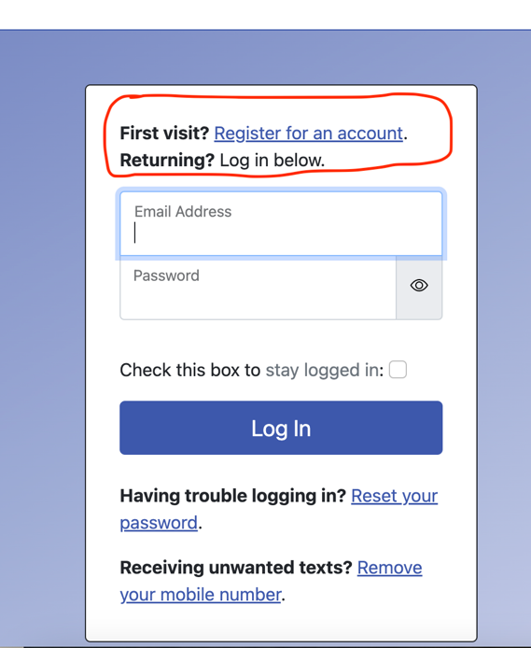

- Once you are logged in, you will see a scheduling grid. You can book an appointment by clicking on any white square and filling out the subsequent form. Appointments in blue or red are not available.

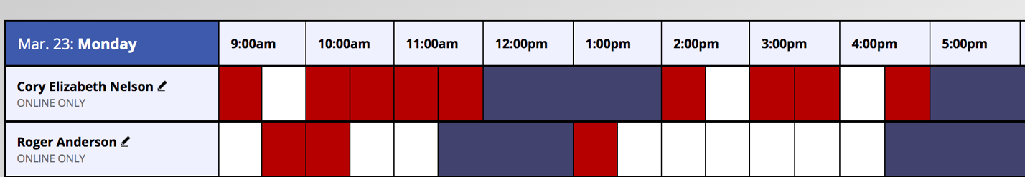

- When booking your session, the system will default to an appointment length of 30 minutes (which means 25 minutes of hands-on work). If you would like to schedule a 60-minute appointment (which involves 50 minutes of hands-on work), simply adjust the ending time by using the drop-down menu.

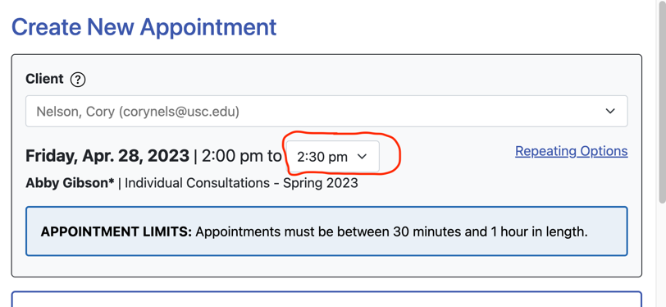

- For many timeslots, you can choose whether to meet your consultant in person or online. When that is the case, you’ll see the choice pictured below. However, if you are looking at the schedule grid and see a consultant’s name with an asterisk beside it, then an online consultation is the only option you will have for that timeslot.

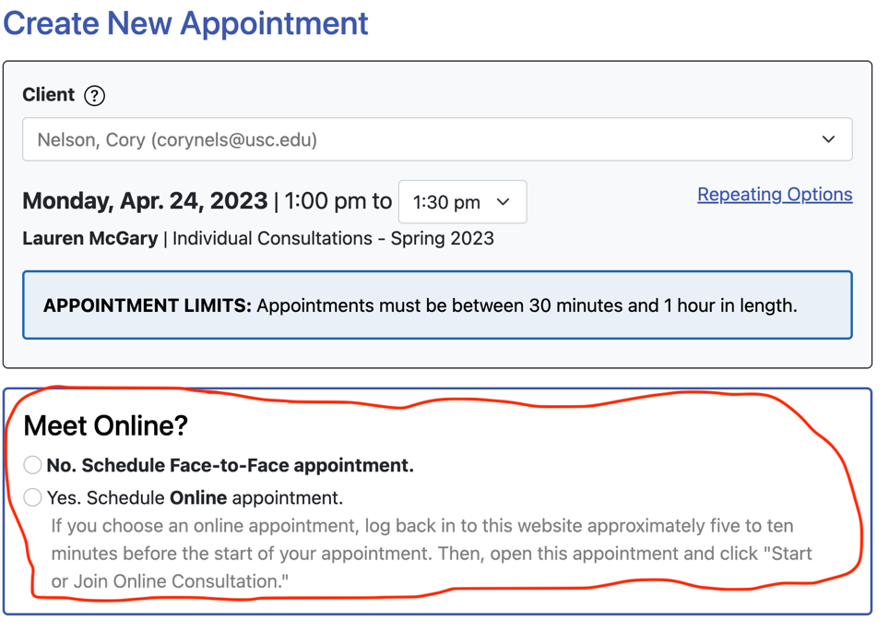

- If you need to cancel or reschedule your online appointment, repeat steps #1 – 4. When you arrive at the scheduling grid, click on your appointment, which will be highlighted in yellow, to modify it.

To Attend an Online Appointment

- A few minutes before your appointment, launch a web browser (we recommend Chrome) and make sure that your computer’s microphone and camera are both enabled. Disable any pop-up blockers or browser extensions that prevent auto-play.

- Log in to the schedule grid by repeating steps #1 – 4. Your appointment will be highlighted in yellow. Click the yellow square, which will launch a pop-up window. Within the pop-up window, click “start or join online consultation.”

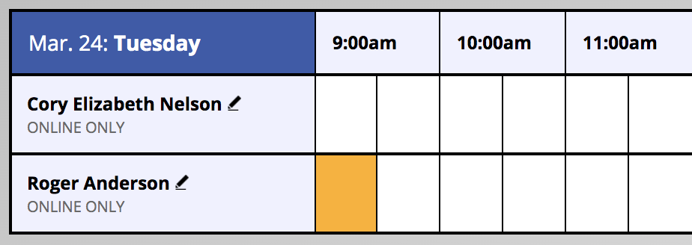

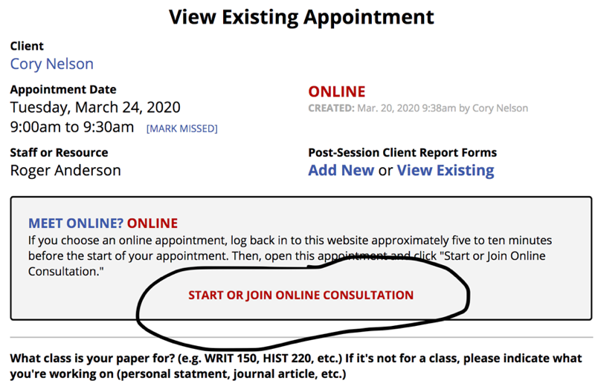

- Your browser may ask if it should allow this website to access your camera and microphone. Click “allow.”

- At this point, you and the consultant should be in a virtual session together. You will see your consultant on the left-hand side of the screen. You will have the option to chat (via text) with your consultant on the right-hand side of the screen. The large document in the center of the screen is the “pad,” where you paste your writing to discuss with the consultant.

- If you get disconnected during a session, close the browser tab. Return to the schedule grid and relaunch the appointment – it should drop you directly back into the session.

- If you have questions or problems, please e-mail writing@usc.edu or call 213-740-3691.

