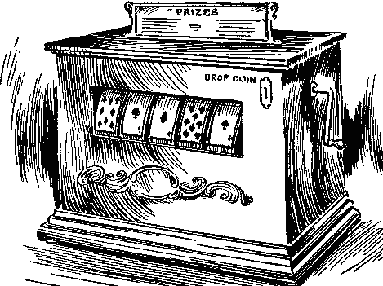
The Sheridan Baker Thesis Machine

There is no formula for developing a strong argument. To develop a creative and multidimensional thesis, you need to consider the assignment at hand, conduct research when appropriate, and devote time to brainstorming.

Nevertheless, the Sheridan Baker Thesis “Machine” is a flexible tool that allows you to organize and streamline your ideas. More specifically, the following questions can help you determine a direction for your argument and see where the gaps may be in your thinking.

- State the topic under consideration. For example:

- Cats
- Writing classes
- Grades

- State the specific issue in the form of a debating proposition. For example:

- Cats should be subject to leash laws.
- Writing classes should be abolished.
- Grades are unnecessary in college.

- Using a “because” clause, convert the resolution into a sentence that states your position on the issue and provides a main rationale for that position [= rough thesis].

- Cats should be subject to least laws because they are inveterate wanderers.
- Writing classes should be abolished because many students are already skilled writers.
- Grades are unnecessary in college because students learn more rapidly without them.

- Polish and refine the rough thesis by adding qualifications (using an although clause) and removing the because clause [= thesis].

- Although it is against a cat’s instinctive wanderlust to be restrained, the crowded nature of city life demands that cats not be allowed to roam around freely.
- Although some students need help developing their writing skills, most high school graduates should be exempt from writing classes in college.
- Although there may be a legitimate need to evaluate the work of college students, the traditional grading system hinders learning and stifles creativity.

- Test your faith in the thesis and explore potential counterarguments by reversing your position.

- The cat’s independent and adaptable nature makes it the only pet capable of living an unrestricted existence within the city.
- Introductory writing classes may be repetitive for high school graduates, but students nevertheless benefit from review and additional practice.
- Traditional grading procedures may offend educational purists, but public-school systems require pragmatic approaches to evaluation.

Adapted from Sheridan Baker, The Practical Stylist

