Body Paragraphs:
Balancing Examples with Explanation

Like a sandwich, each body paragraph in an argumentative essay has certain layers that create the full, mouth-watering main course:

= Topic Sentence

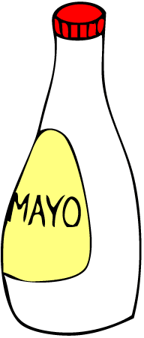

= Example

= Explanation

= Tie back to Thesis

While topic sentences and tie backs are extremely important (academic essays are not on a no-carb diet!), most of us can agree that the meat is what we're all looking forward to when we take the first bite. An academic essay is no different. When revising a body paragraph for greater conceptual depth, it is vital that support (the example) and development (the explanation) are full of flavor.

Begin at the Beginning--at Invention

A body paragraph will only be as strong as the ideas it expresses. In order to troubleshoot this aspect, review your prewriting materials, especially your invention techniques:

- Is your invention material primarily abstract or concrete?
- Did you try to develop detailed and specific support for your ideas?
- Were you able to connect the points you wanted to make to relevant supporting material?

Look for paragraphs that are insufficiently developed and consider what facts or details might be used to strengthen the paragraph's support. In doing this, it often helps to go back over your prewriting materials to see if you can find relevant but unused information.

(over)
How to Troubleshoot Body Paragraphs

After you've identified the weak paragraphs in your essay, choose one to concentrate on, and proceed through the following steps:

1. Color code each aspect of the body paragraph according to its function (topic sentence, lead-up to example, example itself, explanation of example, and tie back to thesis). You can do this on your computer or with highlighters of various colors.

2. Scan the body paragraph. Does the EXPLANATION dominate the color coding? If not, adjust, making sure that the example or quotation itself is short.

3. Scan the paragraph once again and bold or circle all the abstract language. Is there too much bold or too many circles? If so, get as concrete as possible.

4. Now, summarize the overall argument of the paragraph. Does the paragraph connect, in some fashion, to the prompt? (Review it to be sure.)

5. Examine the topic sentence. Does it match the content of the paragraph AND does it connect to the prompt EXPLICITLY? (Look for "key words" from the prompt question).

6. Do the same as #5 for the tie back.

Repeat this process for each of the body paragraphs that need revision.

