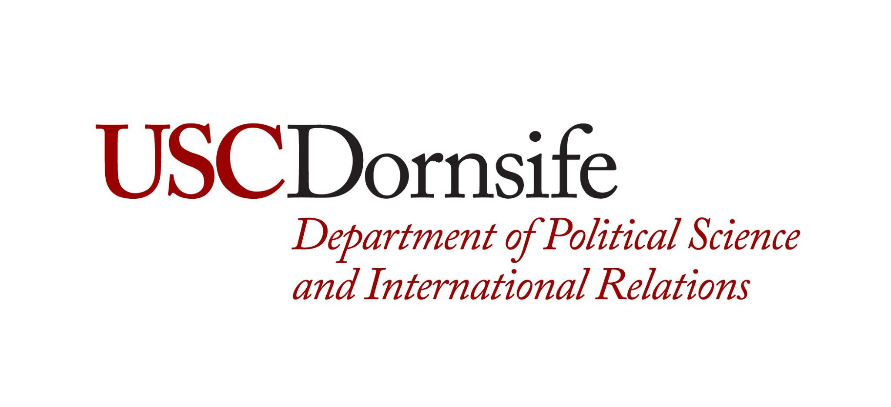
Sherwin Family Advance Graduate Student
Research Support Fund

The Sherwin Family Advance Graduate Student Research Support Fund seeks to support students studying International Relations in their dissertation research and is intended to be used to help cover costs of dissertation research such as travel, lodging, technical support, equipment, etc. Ten students will be selected to receive a $2,500 stipend to help fund their research.

2023-2024 Application (Deadline to Apply: February 26, 2024)
To be eligible for consideration, students must meet the following criteria:
  - Current enrollment in the POIR PhD Program and be in Good Standing.
  - Be nearing completion of your PhD degree (preference given to students who have completed all PhD Requirements except for their dissertation (i.e. completed all course requirements and are ABD))

To apply, students must submit the following:
- A completed cover page, signed by yourself, your faculty advisor, and your PhD Program DGS.
- A short statement about your dissertation research (500 words, max)
- A short statement about what you will use the funds for and why this is essential to your dissertation research
- A letter of support and nomination from a POIR Faculty Member
- A PDF of your anticipated budget
- An updated copy of your STARS report
Applications should be submitted as one PDF Document and uploaded to: https://forms.gle/KGGh6sEcGJLgdi9T9

Student Name: USC ID:________________
Address: Telephone Number:______
Email:____________________________
Cumulative GPA: Major GPA: PhD Start Term:_________
Name of Faculty Advisor:__________________________________________
Student Signature: Date:___________________
Dissertation Chair Signature: Date:___________________
DGS Approval: Date:___________________

