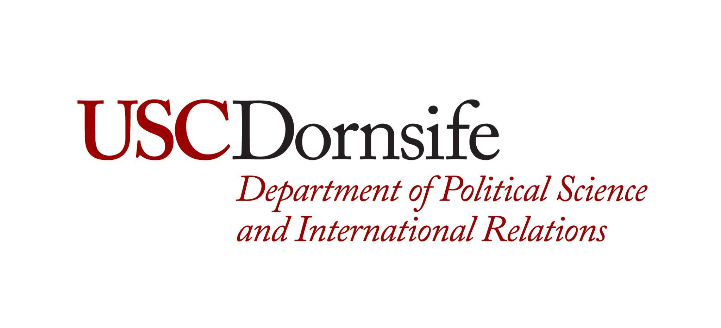
Department of Political Science and International Relations PhD Educational Development Fund Application

Spring 2024
To be eligible for consideration, students must meet the following criteria:
∙ Current enrollment in the POIR PhD Program and be in Good Standing.
∙ The educational development experience must take place during the Spring 2024 semester.

To apply, students must submit the following:
- A short (250 words or less) statement indicating what you will use the funds for and how this is related to your overall educational goals,
- A completed application form with name, event, and fee, signed by yourself, your faculty advisor, and DGS.
- If approved, funds will be distributed after proof of registration has been received, as well as a copy of the program.

Student Name: USC ID:
Permanent Address: Telephone Number:
Email:
Cumulative GPA: Major GPA:
PhD Start Term:

Educational Workshop/Opportunity Requesting Funding Award For:

Associated Cost of Attendance:
Name of Faculty Advisor:
Student Signature: Date:
Faculty Signature: Date:
DGS Approval: Date:

