University of Southern California
DEPARTMENT OF LATIN AMERICAN AND IBERIAN CULTURES
Peru Maymester, Spring 2020

Spanish 499: Special Topics: Language Loss and Deculturation in Cusco, Peru

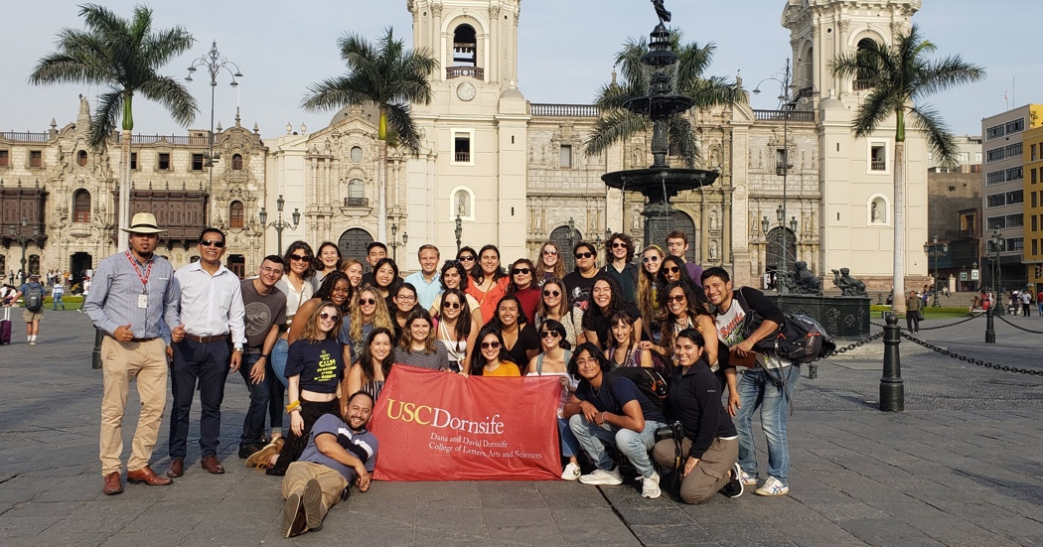

Program Dates:

First meeting: Wed. March 11th (TBA)
At USC: May 18th-21st
In Lima: May 24th-29th
In Cusco: May 29th-June 13th

Section: #62334
Prof. Karen P. Pérez
Email: perezk@usc.edu
Office: THH 156-S
Hours: Tu/Th 11 am-12 pm & by appt.

COURSE DESCRIPTION
This course is an exercise in problem-based learning, whose basic design is for four intensive weeks of classroom preparation, research and fieldwork in Peru. Students will meet in L.A. during the first week and will spend three weeks in Peru: 5 days in Lima and 15 days in Cusco, Peru. During this time, students will attend lectures and briefings, and interview locals and experts, as applicable, to gain deeper knowledge of the complex issues surrounding language and cultural loss in the Andean region. Throughout the entire course, students will use tools of linguistic, literary and cultural studies with specific recommendations for addressing a range of problems associated with Quechua’s loss and Spanish’s gain, deculturation, ethnic discrimination, and other related topics. For this section of the Peru Maymester knowledge of the Spanish language is required* (See “Use of Spanish” on p. 3).

I. Deculturation
Quechua is an official language along with Spanish in Peru. The number of Quechua speakers in Peru is estimated at four and a half million, approximately 19 percent of the total population. However, Spanish is the language of power in all regions, even those in which there are more Quechua speakers, who need to learn Spanish in order to function in their own country, as Spanish is the language of commerce, education, and government. Furthermore, there is a strange contradiction between the pride in the history and culture of the Incas (promoted by government and tourism) and the disdain with which the living descendants of the Inca empire and their language are regarded. The unfortunate result of this widespread negative attitude is that many Quechua speakers hide their linguistic background and speak a broken Spanish with their children, who end up learning a converged version of both languages.
The city of Cusco is a regional capital and was once the capital of the Inca Empire; however, Quechua is nowadays rarely seen in the media. Not even a single newspaper or magazine is published in Quechua and the only written Quechua to be found is in academic works on linguistic, literary or musical topics. There are only few private radio stations that broadcast music, news, or personal announcements for people in isolated communities. Moreover, the Academy of the Quechua Language seems to be languishing for lack of real government support. For all these reasons, it can be argued that unless steps are taken to protect and promote the Quechua language in the public sectors, there is a real possibility that it will decline in importance to the point that it will no longer be used with any frequency, as seems to be the fate of minority languages all over the world.
II. Historical Background
In 1528, Spanish ‘conquistadores’ came upon a vast Inca empire, which stretched across the Andes from what is today southern Colombia to northern Argentina. By the end of 1532, the last Inca king had been killed and the empire was in ruins. A campaign of military, political, economic and cultural conquest had just been born. The Spanish colonial domination lasted for three centuries and shaped the social and cultural settings of Quechua, the language of the Inca nation, and its speakers. In 1824 the Spanish rulers were expelled from former Inca territories and the then-newly born Republic of Peru; however, their language and culture is nowadays still influencing and transforming the lives of the descendants of the Incas and the descendants of those whom they had subjugated. To some extent all of these have maintained several of their older practices and languages despite this continuous strong Spanish influence. But how much longer will Inca descendants be able to hold on to their old traditions, culture and language? The current political and social context in which Quechua coexists with Spanish in Peru does not seem ideal and raises the question whether or not Quechua can survive in a country where their speakers tend to be victims of ethnic discrimination and in a globalized world where Spanish has become the second language by number of native speakers.

III. Course Objectives
- To familiarize students with the history, politics, economy, culture, society, and culinary traditions of Peru.
- To encourage critical thinking and analysis about the real meaning of language death in the world along with its cultural and social consequences.
- To foster a "problem solving" approach in response to the challenges and concerns of under-represented, minority, and indigenous peoples of Peru.
- To inform students about the structure and functions of the Peruvian governmental components with oversight responsibility for Quechua protection policies and programs and how they are formulated, debated, managed, and implemented. Similarly, to inform students about non-governmental organizations active in pro-Quechua matters.
- To provide students with an opportunity to volunteer and experience the way of life of one of the many indigenous communities in Cusco, Peru.

IV. Course Evaluation
Students will be graded on three elements of the class. The first element is their knowledge of contents, which will be assessed through two reading quizzes focusing on the historical background of the problem and a final exam. The second element is based on students’ performance which includes timeliness, participation, and cooperation essential to the success of the numerous meetings and discussions that will take place as well as a critical essay reflecting the cultural learning experience. The third element will be a presentation discussing a major culture and/or language loss-related topic.

Summary of Distribution of Grades
- 2 Reading Quizzes 20%
- Class Participation 10%
- Use of Spanish 5%
- Critical Essay 15%
- Presentation 25%
- Final Exam 25%

1. Two Reading Quizzes (20%)
The quizzes will cover the material covered in all lectures, readings, student presentations, and guided tours. This also includes the material covered during the first week of classes at USC.

2. Class Participation (10%)
- In classroom:
Preparation of readings and active participation, and contribution to lectures, discussions, and related excursions are mandatory. The grades will reflect each student’s commitment. Be ready to answer questions such as:
- What does the reading/documentary discuss?
- How does this reading/documentary inform my understanding of culture/Peruvian culture?
- In what ways can I contribute to the class discussion? (Consider examples or additional questions the group ought to discuss in light of the reading/documentary)
- Visits/ Field Trips
- The visits indicated on your syllabus are mandatory
- Expect to always have a discussion after the visit
- Always arrive at the meeting places at least 10 minutes before the scheduled departure time
- Most visits have a local guide, so take opportunity to ask questions

3. Use of Spanish (5%).
The use of Spanish is expected during all course-related activities. Including, lectures, guided tours and class participation. While the class is conducted in Spanish and all student presentations are in Spanish, students not seeking Spanish credit have the option of submitting their final paper and taking all examinations in English for English credit.

4. Critical Essay (15%)
The critical essay is a composition that should offer an analysis, interpretation, commentary, and/or evaluation of texts, lectures, and visits. Make sure that your essay considers how your cultural experiences have been affected by your previous knowledge, and how they have been changed/affected by the course readings, visits, and lectures. Your entry should have at least 1000-1500 words and should consider the readings, visits, and other cultural observations you made on your own. Be conscious of the language used, these are academic essays.

5. Presentation (25%)
All articles are in English. Each student will present and lead the discussion of an article in Spanish, as indicated on the syllabus. He or she will prepare questions to discuss and lead the group discussion.

6. Final Exam (25%)
The Final Exam, essay style, is comprehensive and will take place in the last day of the program in Peru.

V) Student Accommodations
In Lima, students will stay at El Tambo Hotel in the District of Miraflores. While in Cusco, students will stay with local community homestay families. All families will provide a room, food, and sanitary living conditions for students. All of these families are carefully selected and trained. They are used to hosting foreign exchange or study abroad students.

VI. Class location
While in Peru, all lectures and discussions will take place at the School of Communication, Tourism and Psychology of the University San Martin de Porres (in Lima) http://www.fcctp.usmp.edu.pe/
and at the Cusco Extension Center of Universidad San Ignacio de Loyola (in Cusco), a recently-refurbished building with both pre-Hispanic and colonial features located in the historic center of Cusco, just two blocks away from the main plaza http://internacional.usil.edu.pe/en/international/study-at-usil/study-cusco
Universidad San Ignacio de Loyola (USIL) belongs to the San Ignacio de Loyola Education Corporation, a global organization with over 48 years of experience in the education sector that specializes in every level of teaching, from the preschool level at the Coloring Dreams early childhood education center, through graduate studies at the USIL Graduate School. The corporation has operations in the United States, Peru, Paraguay and China, as well as agreements with more than 220 strategic partners in the Americas, Asia, Europe and Oceania http://www.usil.edu.pe/en.

These are some of the facilities and areas that will be available to this program throughout its entire duration.
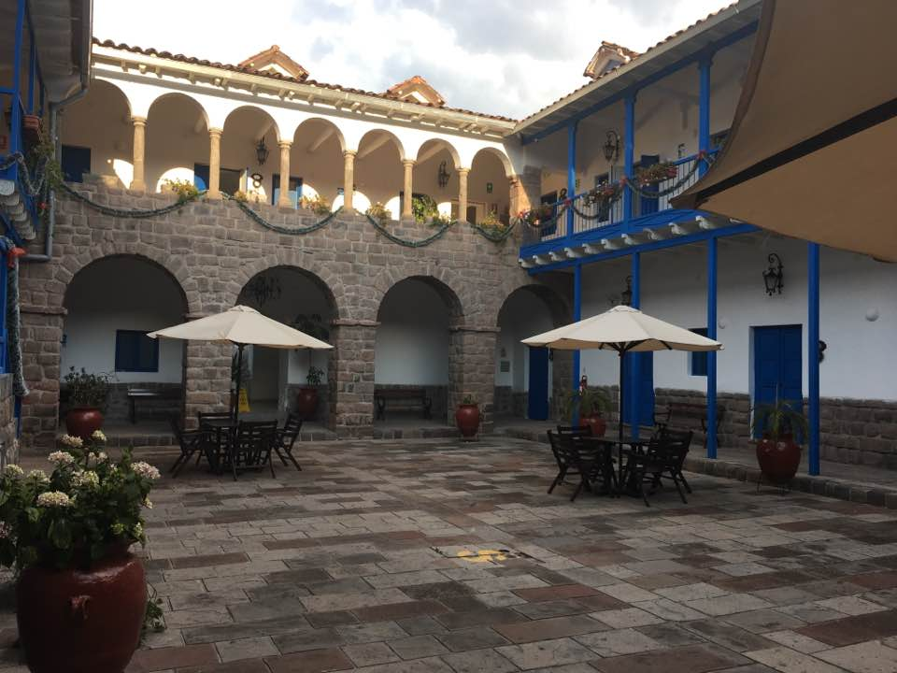
Cusco Extension Center Main Patio

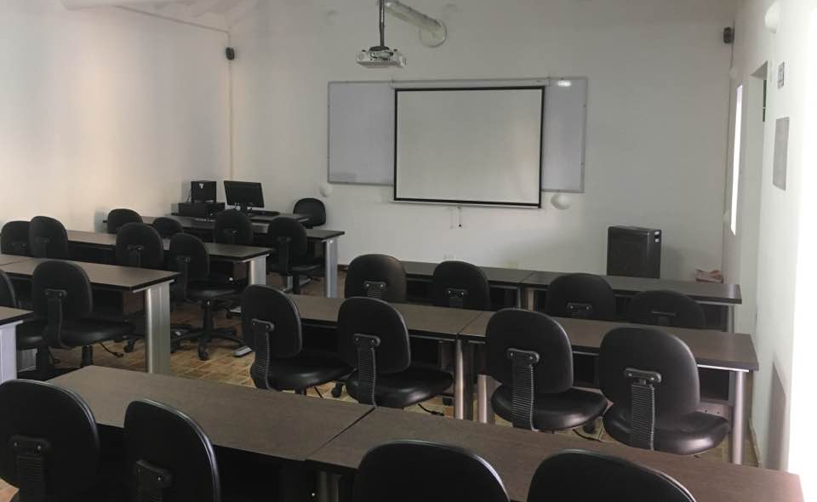
Classroom with projection and multimedia equipment
VII. Class Itinerary (Subject to Change due to program requirements, building renovations or closures, holidays, inclement weather, safety precautions or any other unforeseen circumstance)

Program Dates:
At USC: May 18-21
In Lima: May 24-29
Tentative
In Cusco: May 29-June 13

*Discussion topics and readings
*Evaluations
*Field Trips and Visits

In Los Angeles

May 18 (Monday): Introduction to the program & course syllabus

What is Culture?
Glover, Jerry a., and Harris L. Friedman. (2015) An Approach to Cultural Differences.

May 19 (Tuesday): Pre-Inca Cultures
Lanning, Edward P. (1967) “Peru Before the Incas.” Englewood Cliffs: Prentice Hall

May 20 (Wednesday): History of the Quechua Languages
- Itier, Cesar (2002) Quechua, Aymara, and other Andean Languages: Historical, Linguistics and Sociolinguistics Aspects. Peruvian Cultural Centre.

May 21 (Thursday): Current situation of Quechua in South America and Types of Quechua
Speakers.
- Adelaar, Willem F. (2014) "Endangered languages with millions of speakers: Focus on Quechua in Peru". Ludwig-Maximilians Universität München.

May 22 (Friday): Free Day

May 23 (Saturday): Trip to Peru. (You may depart at any time, but please make sure that your check in at the hotel in Lima on May 24 after 1pm. No lodging is covered nor arrangements have made for you for the night of May 23rd)

In Lima

May 24 (Sunday): Arrival in Lima. Welcome dinner. Check in after 1 pm
Meals included: Dinner (only)

May 25 (Monday): Conquest and Colony
- Mother Earth Travel Organization (2000) Spanish Conquest and Colonial Times. Source: Area Handbook of the US Library of Congress

The Viceroyalty of Peru: Development of ethnicities

-Historic Downtown: Plaza de Armas (Main Square), Government Palace, Cathedral, Church and Monastery of Santo Domingo
-District of Barranco: Plaza de Armas (Main Square), Cathedral, Ermita Church, Bridge of Sighs

Meals included: Breakfast at hotel (only). Maybe dinner in Barranco (TBD)

May 26 (Tuesday): The Birth of the Republic of Peru
- Henderson, Peter V. N. “The Wars for Independence, 1808-1830.”
Course of Andean History, U of Mexico Press, 2013, pp. 107-19.

- Walker, C. (1998). “The Patriotic Society: Discussions and Omissions about Indians in the Peruvian War of Independence”. The Americas, 55(2), 275-298.

-Larco Museum
-Circuito Mágico del Agua del Parque de la Reserva

Meals included: Breakfast at hotel (only)

May 27 (Wednesday): Quiz 1 (Location TBD)

-La Punta District Callao and Real Felipe Fortress
-Cultural Event: Brisas del Titicaca (Night of Folklore event)

Meals included: Breakfast at hotel (only)

May 28 (Thursday): The War against Terrorism and its Consequences on Indigenous Populations
The War of The Pacific and Peruvian Nationalism

- Ortega, Luis (1984) “Nitrates, Chilean Entrepreneurs and the Origins of the War of the Pacific”. Journal of Latin American Studies, Vol. 16, No. 2. 337-380
- Starn, O. (1995). Maoism in the Andes: The Communist Party of Peru-Shining Path and the Refusal of History. Journal of Latin American Studies, 27(2), 399-421.

-Visit to the ancient Lima: Tour Huacas (Pucllana & Huallamarca)

***Every one packs tonight!!!
(Flight to Cusco tomorrow early morning)

Meals included: Breakfast at hotel (only)

In Cusco

May 29 (Friday): Flight to Cusco / Transfer to Homestay families/ Rest and acclimatization

Meals included: Meals at homestay. Students: If you decide to eat out, please have light meals only like chicken soup (dieta de pollo) or something similar due to the altitude. Please inform your homestay family every time you will not eat at home.

May 30 (Saturday): Origin of the Empire and the Kingdom of Cusco, Formation, Expansion and Consolidation of Tahuantinsuyo.
- Henderson, Peter V. N. (2013) “The Inca and the Late Horizon, 1400-1532.” Course of Andean History, U of Mexico Press, pp. 38-49.

-City tour (Approx. 3-hour walking): Plaza de Armas (Main Square), San Blas and Qoricancha (Temple of the Sun)

Meals included: All meals at homestay. (*Optional: students may want to try different eateries at the Plaza at any time and skip their homestay meals. If so, please inform your homestay mom ahead of time)

May 31 (Sunday): -Cusco Four Ruin Tour (full-day): Saqsaywaman Fortress, Qenqo
Archaeological Site, Puka Pukara Fortress and Tambomachay
Archaeological Site

Meals included: Breakfast and dinner at homestay. Lunch: on your own

Jun 1 (Monday): Inca Society
- Von der Heydt-Coca, M. (1999). When worlds collide: The incorporation of the Andean world into the emerging world-economy in the colonial period. Dialectical Anthropology, 24(1), 1-43.

- Murdock, G. (1934). The Organization of Inca Society. The Scientific Monthly, 38(3), 231-239.

Quechua class

Meals included: All meals at homestay.

Jun 2 (Tuesday): -(Cusco South Valley): Tipon Archaelogical Park, Pikillaqta archaeological Complex and Andahuaylillas

Meals included: Breakfast and dinner at homestay. Lunch: on your own.

Jun 3 (Wednesday): Religious Synchretism, ‘Mestizaje’ and Society of Castas
- Henderson, Peter V. N. (2013) “Indigenismo and Mestizaje: New Ideas About Nation, 1920-1980.” Course of Andean History, U of Mexico Press, pp. 212-24.

- De la Cadena, Marisol. (2001) “Reconstructing Race: Racism, Culture
and Mestizaje in Latin America.” NACLA Report on the Americas,
vol. 34, no. 6 pp. 16-23.

Meals included: All meals at homestay

Jun 4 (Thursday): Civil War and Fall
- Rowe, J. (2006). The Inca civil war and the establishment of Spanish
power in Peru. Ñawpa Pacha: Journal of Andean Archaeology, (28)

-City tour (3-hour walking): Historical Regional Museum, and San Pedro Market (depending on weather)

***This evening you have to pack for Machu Picchu!!!
(Our 3-day excursion. Go to bed early. You have to eat breakfast very early. We depart at around 6:30 am tomorrow. Pack light, no backpacks heavier than 8 kilos [17.6 lbs.] to Machu Picchu)

Meals included: All meals included. Unless student decides to buy lunch at the Plaza

Jun 5 (Friday): Cusco-Sacred Valley: Chinchero, Moray, Maras (salineras), short walk from Salineras to the restaurant and Ollantaytambo
(Lodging in the Sacred Valley)

Meals included: Breakfast included at homestay. Buffet lunch included. Dinner on your own

Jun 6 (Saturday): Sacred Valley: Activities
-Tentatively: one of the following activities:
1. Huayllafara Community Hike
2. Lamay Community Day
3. The Bee Sanctuary Experience
(Lodging in Aguas Calientes – closest town to Machu Picchu)

Meals included: Breakfast included at the hotel. Lunch and dinner on your own

Jun 7 (Sunday): Sacred Valley: Machu Picchu- Cusco

*We hike Machu Picchu today

Meals included: Only breakfast included at the hotel. Lunch and dinner on your own

Jun 8 (Monday): Current cases of Stigmatization and Revitalization of Quechua
- Coronel-Molina, Serafin M. (1999) “Functional Domains of the Quechua Language in Peru: Issues of Status Planning.” International Journal of Bilingual Education and Bilingualism, vol. 2, no. 3, pp. 166-80.

- Coronel-Molina, S. (2011) Revitalization of Endangered Languages: Quechua in the Andes. Droit et Culture. p. 105-118.

*Evening lecture (probably 4-6pm)

Meals included: Breakfast, lunch and early dinner included at your homestay. Optional: students can skip dinner and eat at the Plaza.

Jun 9 (Tuesday): Indigenous Community Activity

Meals included: All meals included at homestay. If eating out, please inform your homestay mom

Jun 10 (Wednesday): Quiz 2
-Peruvian hands-on Cuisine Class

Meals included: All meals included at homestay

Jun 11 (Thursday): Free day
Critical Essay due

Meals included: Breakfast and dinner included at homestay. Lunch on your own

Jun 12 (Friday): Final Exam
Farewell Dinner

Meals included: Breakfast and lunch included at homestay.

Jun 13 (Saturday): End of Program. Transfer to Cusco Airport.

VIII. Recommended Additional Readings and Downloads

Download (to view online books, Mac or Windows): Adobe Digital Editions at http://www.adobe.com/solutions/ebook/digital-editions/download.html and create an ID.

Bebout, Lee. “Postracial Mestizaje: Richard Rodriguez’s Racial Imagination in an America Where Everyone is Beginning to Melt.” American Studies, Vol. 54, no. 1, 2015, pp. 89-113.

Coronel Molina, Serafin M. “Language Ideologies of the High Academy of the Quechua Language in Cuzco, Peru.” Latin American and Caribbean Ethnic Studies, vol. 3, no. 3, 2008, pp. 319-40.

D’Argenio, Maria Chiara. “A Contemporary Andean Type: The Representation of the Indigenous World in Claudia Llosa’s Films.” Latin American and Caribbean Ethnic Studies, vol. 8, no. 1, 2013, pp. 20-42.

Hornberger, Nancy H. “Bilingual Education Success, but Policy Failure.” Language in Society, vol.
16, no. 2, 1987, pp. 205–226.

Hornberger, Nancy H. “Can Peru’s Rural Schools be Agents for Quechua Language Maintenance?” Journal of Multilingual and Multicultural Development, vol. 10, no. 2, 1989, pp.145-159.

Hornberger, Nancy H. and Kendall A. King. “Language Revitalisation in the Andes: Can the Schools Reverse Language Shift?” Journal of Multilingual and Multicultural Development, vol. 17, no. 6, 1996, pp. 427-41.

Kalt, Susan E. “Spanish as a Second Language When L1 Is Quechua: Endangered Languages
and the SLA Researcher.” Second Language Research, vol. 28, no. 2, 2012, pp. 265–279.

Lefebvre, Claire. “Quechua's Loss, Spanish's Gain.” Language in Society, vol. 8, no. 3, 1979, pp.
395–407.

Mannheim, Bruce. “Una Nación Acorralada: Southern Peruvian Quechua language planning and politics in historical perspective” Language in Society, vol. 13, 1984, pp. 291-309.

Pagan-Teitelbaum, Iliana. “Glamour in the Andes: Indigenous Women in Peruvian Cinema.” Latin American and Caribbean Ethnic Studies, vol. 7, no. 1, 2012, pp.71-93.

IX. Statement on Academic Conduct and Support Systems

Academic Conduct:
Plagiarism – presenting someone else’s ideas as your own, either verbatim or recast in your own words – is a serious academic offense with serious consequences. Please familiarize yourself with the discussion of plagiarism in SCampus in Part B, Section 11, “Behavior Violating University Standards” https://policy.usc.edu/scampus-part-b/. Other forms of academic dishonesty are equally unacceptable. See additional information in SCampus and university policies on scientific misconduct, http://policy.usc.edu/scientific-misconduct.

Support Systems:
Student Counseling Services (SCS) - (213) 740-7711 – 24/7 on call
Free and confidential mental health treatment for students, including short-term psychotherapy, group counseling, stress fitness workshops, and crisis intervention. https://engemannshc.usc.edu/counseling/

National Suicide Prevention Lifeline - 1-800-273-8255
Provides free and confidential emotional support to people in suicidal crisis or emotional distress 24 hours a day, 7 days a week. http://www.suicidepreventionlifeline.org

Relationship & Sexual Violence Prevention Services (RSVP) - (213) 740-4900 - 24/7 on call
Free and confidential therapy services, workshops, and training for situations related to gender-based harm.https://engemannshc.usc.edu/rsvp/

Sexual Assault Resource Center
For more information about how to get help or help a survivor, rights, reporting options, and additional resources, visit the website: http://sarc.usc.edu/

Office of Equity and Diversity (OED)/Title IX compliance – (213) 740-5086
Works with faculty, staff, visitors, applicants, and students around issues of protected class. https://equity.usc.edu/

Bias Assessment Response and Support
Incidents of bias, hate crimes and microaggressions need to be reported allowing for appropriate investigation and response. https://studentaffairs.usc.edu/bias-assessment-response-support/

Student Support & Advocacy – (213) 821-4710
Assists students and families in resolving complex issues adversely affecting their success as a student EX: personal, financial, and academic. https://studentaffairs.usc.edu/ssa/

Diversity at USC – https://diversity.usc.edu/
Tabs for Events, Programs and Training, Task Force (including representatives for each school), Chronology, Participate, Resources for Students.

