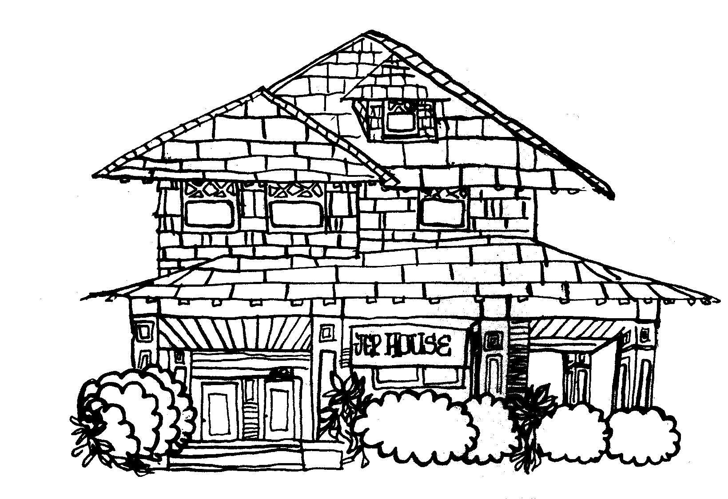

**JOB ANNOUNCEMENT**

**50% GRADUATE ASSISTANTSHIP (STEM Education)**

The Joint Educational Project (JEP) is a service-learning program housed in the University of

Southern California’s Dornsife College of Letters, Arts and Sciences. JEP was established in 1972 to link traditional classroom-based learning with educational experiences in the community surrounding USC’s main campus. The program seeks to foster the intellectual, social and ethical development of USC students while providing valuable services to community schools and organizations.

**JEP is looking for a graduate student to work with JEP staff to develop curricula for our STEM Education Program.**

The ideal candidate will have:

* An understanding of STEM communication practices
* Familiarity with the JEP program
* An interest and ability to engage with material outside of one’s discipline
* The ability to work independently and in collaboration with others
* The ability to think creatively about teaching and learning processes
* A desire to contribute to research projects stemming from our work with students and the community
* Availability to attend a pre-semester training (in-person, if circumstances allow) and weekly staff meetings (Monday evenings)

Job responsibilities include:

* Working with JEP STEM Education staff and faculty to develop curricula for K-5 students
* Providing training and support for undergraduate STEM instructors
* Preparing reports, grants and other documents
* Working with faculty to develop broader impacts for their research
* Designing new program elements as needed and in conjunction with JEP staff Other requirements:
* Must be able to work on-site at the JEP House 2 days per week (hours flexible and, depending on the University’s COVID-19 policies, work may be virtual)
* *To qualify for the 50% graduate assistantship, candidates must be enrolled as a Ph.D. student in a Dornsife department for the 2024-2025 academic year*

Applications are available or online at https://dornsife.usc.edu/joint-educational-project/work-at-jep/.

**DEADLINE: The application deadline is Friday, November 8th, 2024.**

Please contact Dr. DJ Kast (dkast@usc.edu) and/or Jessica Stellmann (stellman@usc.edu) for more information about the position.

# JEP STEM EDUCATION

**GRADUATE ASSISTANTSHIP APPLICATION**

Name: ___________________________________________________

USC Student ID#: ___________________________________________

Permanent Address: _________________________________________

_______________________________________________________

Local Address (if different from above): ____________________________

_______________________________________________________

Telephone: __________________ email: ________________________ Emergency contact: _________________________________________

(name, relationship and telephone number)

Major field of study (2-4 letter code) and expected terminal degree: _________

Semester admitted to current graduate program: _____

Semester/year you expect to graduate: _____

International student? ___ Yes ___ No

Research interests, skills and/or areas of specialization: _________________

_______________________________________________________

_______________________________________________________ _______________________________________________________

_______________________________________________________

Teaching assistantship(s)? Yes No

Classes, dates, institution(s) and professor(s)

_______________________ _______________________

_______________________ _______________________

Have you been a Teaching Assistant for a course that worked with JEP? Yes No

If yes, please indicate: ___________________________________

Research assistantship(s)? Yes No

Type of research, dates, institution(s) and professor(s) (if at USC)

_______________________ _______________________

_______________________ _______________________

Have you ever taken a service-learning course? Yes No

If yes, briefly describe:

_______________________________________________________

_______________________________________________________

_______________________________________________________

_______________________________________________________

Sources of funding for the upcoming school year: ______________________

_______________________________________________________

What are your plans for employment after graduation? _________________

_______________________________________________________

_______________________________________________________

References (please include at least one USC professor or staff member):

name position phone number

1. ______________________________________________________
2. _____________________________________________________
3. _____________________________________________________

Please include the following with your application:

* 1. A brief personal statement (1-2 pages) that describes your educational philosophy and perspectives about (and/or experiences with) STEM Education
  2. A copy of your resume or C.V., including a summary of your educational, research, teaching, employment, and community experiences
  3. A letter of recommendation from someone familiar with your abilities and experience.

(Recommenders may email letters directly to JEP, attention: Dr. DJ Kast, dkast@usc.edu )

**APPLICATIONS ARE DUE FRIDAY, Nov 8th, 2024**

Please email application to Dr. DJ Kast, dkast@usc.edu.