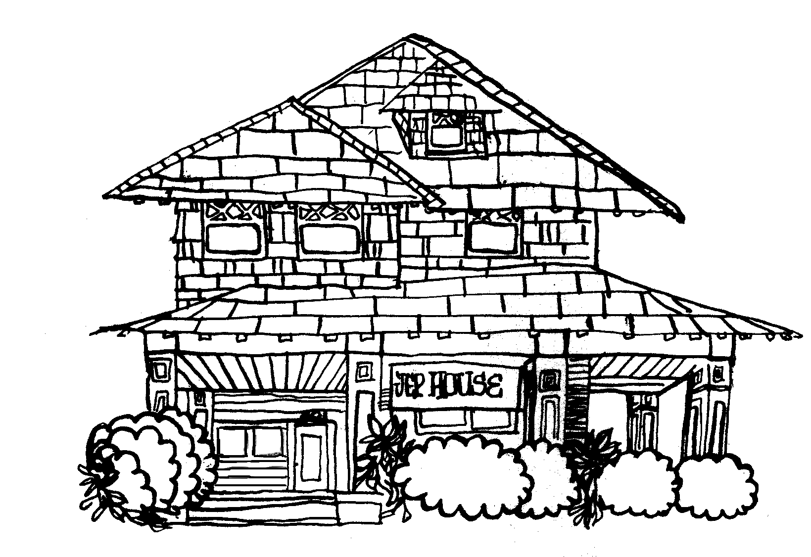

The Dick Cone Award for Graduate Engaged Scholarship

USC has a long tradition of undergraduate service-learning and community engagement. Every year, thousands of undergraduate students hone civic skills and apply academic concepts through community service in local schools and organizations. The civic and community engagement work of graduate students at USC is less well-recognized, however, despite the fact that many graduate students produce engaged scholarship and provide advanced professional skills that support the public good.

Named in honor of Richard “Dick” Cone—JEP’s Executive Director from 1980-2002—the Cone Award is intended to honor and recognize the efforts of graduate students who bring advanced awareness and skills to address specific needs in the community. This work can take a variety of forms, including:

- A research project conducted with or on behalf of a community agency or organization;
- A film, article or other media project that addresses community concerns, gives voice to and/or assists community agencies or institutions in carrying out their missions;
- Curricula designed to address some identified community need;
- A grant-funded project written with or on behalf of a community agency or institution;
- Pro bono professional consultation;
- Any other work that promotes community development/empowerment and is structured in such a way that it will be maintained beyond the time the student is guiding it.

One student will be named the 2024 Cone Scholar and will be recognized at the annual JEP Volunteer Awards Dinner on April 10th, 2024. The honor comes with a $500 stipend. Non-progressive degree Master and Doctoral students are eligible. Finalists will be invited to interview in March and, if selected, will be notified shortly thereafter.

Apply by March 15th, 2024, 11:59PM. Please include the following in your application:
- A copy of your CV.
- A brief (~1-2 pages) statement explaining why you believe your work is worthy of recognition, based on the above or similar criteria.
- A letter of support/recommendation from a faculty member, community partner or anyone who is familiar with your engaged scholarship.
- A photograph that reflects your community service efforts that we could include in an awards ceremony if you are chosen to receive an award. Be creative! If you do not have any pictures that directly capture your engagement, consider other representations of your contributions to community. (Note that any pictures of children require parental consent prior to distribution.)
Email Samantha Bernstein-Sierra, Ph.D. (srbernst@usc.edu) with nominations or any questions.

