AMERICANS and NATURE

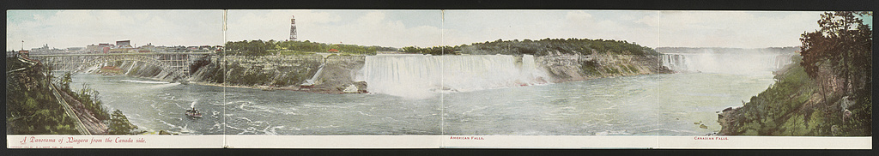
A Panorama of Niagara from the Canada Side, 1903
Library of Congress, Prints & Photographs

University of Southern California
Dornsife College of Letters, Arts, and Sciences
Fall Term, 2022

Thematic Option
CORE 104: Change and the Future
Americans and Nature
Thursdays 1:00 to 4:00

Location: Sidney Harman Academy for Polymathic Study space
Second Floor, Doheny Memorial Library

Professor William Deverell
deverell@usc.edu
Office Hours: by app’t
History Department, 2nd floor, SOS Bldg.

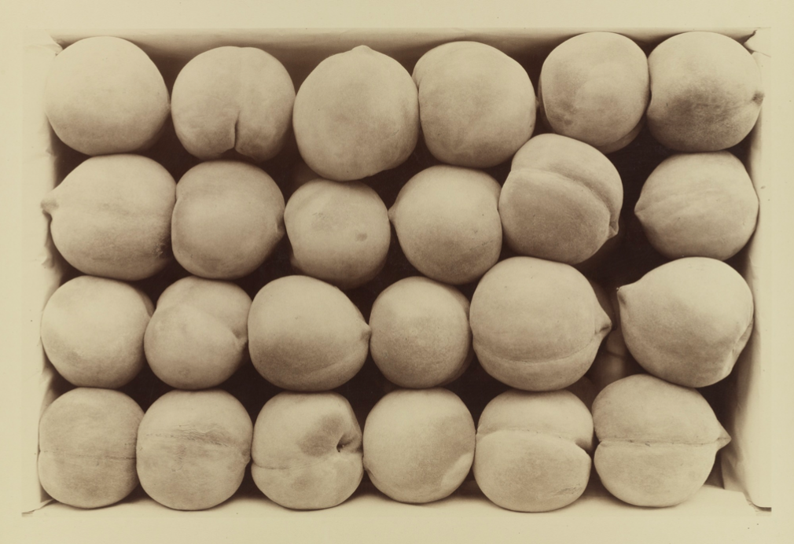
Late George Cling Peaches, Carleton Watkins, 1889. The Huntington Library

Course Objectives and Themes
The history of the United States is tied peculiarly and particularly to conceptions of nature. These ideas and expectations have often been mixed with or built upon various attachments to (and convictions about) nationalism. From the era of Old World/New World contact unto today, the trajectory of American history has touched deeply upon meanings drawn from perceptions of nature.

This course explores those perceptions of American Nature through history and literature. Our aim will be to discover shifts in perceptions over time, both as the national trajectory changes and as nature in view, review, and experience changes. Students will explore fiction, poetry, history, and historical and literary scholarship. We will be especially focused on the regional and temporal differences germane to colonial history, the early Republic, the Civil War era, and the first and second halves of the 20th century. Although we will move through historical periods hewing to conventional ways in which eras are described. In other words, we will be open to new ways to divide or periodize American history by reference to nature and ideas about how nature and American relationships to it change. Could we think of other ways to define American eras and epochs if nature becomes our chief analytical prism? Our work together will also examine the visual record of American views of nature, especially as expressed through painting and photography.

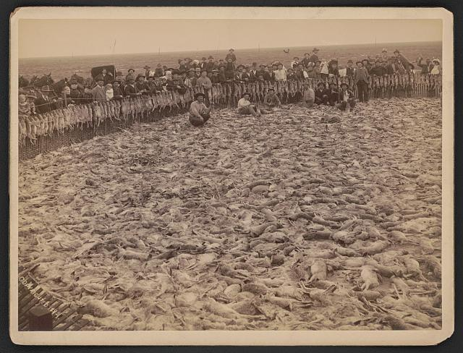
Grand Army of the Republic Rabbit Drive, Fresno, California 1892

Our time together will move rapidly. We will honor and hew closely to the three stated educational and intellectual goals of Thematic Option, namely that:

- Students learn to think across disciplines, to not be constrained by the methods and concepts of any one approach.

- Students develop a love of language, an appreciation for the power of the written and spoken word. Through Thematic Option’s writing seminars students learn to express themselves cogently and concisely as excellent writers. Through the CORE curriculum courses, students get a sense of the history of ideas, along with the ability to discuss it critically and open it up to inquiry.

- Students learn to deal with ambiguity. Thematic Option courses are not about providing answers, but asking questions. What is truth? What is justice? Who am I? What responsibilities do I have to society? These are but a few of the grand questions with which Thematic Option students struggle as they become comfortable with the realm of uncertainty, an open space full of opportunities for exploration.

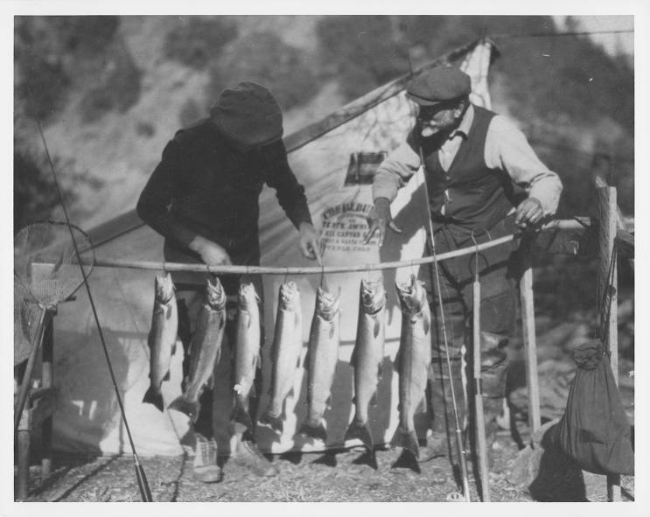\
Astronomer Ferdinand Ellerman, circa 1920. The Huntington Library

Course Meetings and Assignments
You are expected to be in every class. I expect you to come prepared and to participate. Unexcused absences are frowned upon and will affect your grade. Excused absences ought to be very few. You are encouraged to take notes in this class, as you will do better if you do. Please feel free to take notes however you wish. However, please do not utilize your laptop, phone, tablet, etc. for anything other than note taking unless the opportunity presents itself for us to look something up via your device. You are of course expected to do your own work; violations of academic integrity, cheating, plagiarism, and the like are taken very seriously by your professor and the university, the College, the history department, and everyone in the academic community.

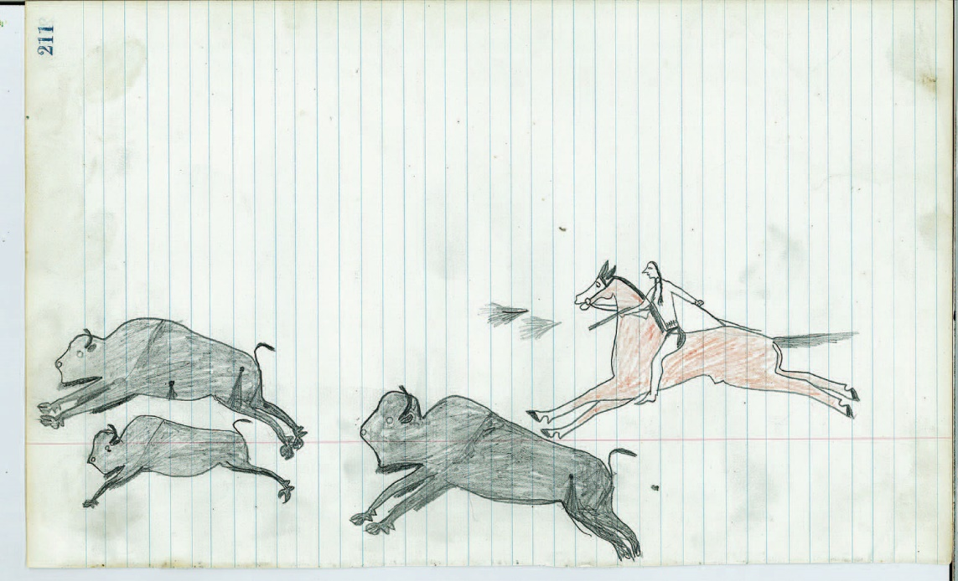
Hunting buffalo. Native American Ledger Art. n.d., ca. 1880s. Courtesy H. Malcolm Grimmer

Course Readings
We read a lot of books in this class. They are all required. Please have the relevant books or parts of books read by the time we begin class each week. In no particular order, the books for the term are these:

William Cronon, Changes in the Land.
Pilgrims, Puritans, explorers, adventurers: did they find virgin land? No. They found lands filled with people who, over millennia, had changed every landscape they encountered and lived in.

Stephen Pyne, Year of the Fires.
How megafire changed America in the early twentieth century.

Norman McLean, Young Men and Fire.
You will not be the same after reading this book.
William Faulkner, The Bear.
Kind of a break from all the history, kind of not a break: Faulkner is never easy.

Jon Krakauer, Into the Wild.
The short and wild life of a young, headstrong, principled, naïve, ill-prepared man; heartbreaking, meaningful or meaningless?

Henry David Thoreau, Walden.
This was once required reading of educated young people in America. But go slow: it can bog down, it can be dense, and it is more complicated and perhaps less clear than we would wish for it to be. Would you go into nature to live deliberately? Why and for how long? Where?

Gary Snyder, No Nature.
Arguably the greatest American poet of the 20th century.

Walt Whitman, Leaves of Grass.
Arguably the greatest poet in American history.

Annie Proulx, Bird Cloud.
An environmental and personal reckoning by the author of the story that became Brokeback Mountain.

Amy Irvine, Desert Cabal.
Is it a love letter to a revered and quixotic environmental warrior? Is it the opposite? Both?

Rachel Carson, Silent Spring.
Used to be required reading for college students interested in nature and assaults upon it, insults enacted in it. Required again!

Nathaniel Hawthorne, May-Pole of Merry Mount, Ambitious Guest, and Young Goodman Brown short stories

Course Exercises and Assignments
This course has one in-class assignment and three substantive exercises and assignments. The exercises are due on their respective due dates (or earlier, but not later). You are also graded upon your participation. Your grade breakdown is as follows: short essays, 20% each; midterm 20%; final essay 30%, participation 10%.

In-class assignment. Using a sign-up list, each of you will read aloud in class one “nature poem” or “nature stanza” of your choosing from an American poet, living or dead. You may excerpt your reading if the poem is very long. We are looking for something of only a minute or two in duration. We want to know who the poet is, their dates, the title of the poem, and the reason why you choose to read it (or part of it). This will hopefully happen at the start of each week’s class, and we will have to hear from several of you each week. Some people, through no fault of their own, are loathe to stand and speak in public. While I would like to encourage all of you to read aloud to your classmates, you are permitted to record yourself reading and play that for us.

Two Short essays. 1,000 words or less. The first one is due September 15th at the start of class, the second one is due October 20th at the start of class, in hard copy please (proofread and spellchecked). For these, choose two of the following prompts (there is no order).

Discuss the theme/idea/meaning of nature in one of the following documents: the US Constitution, the Declaration of Independence, the inaugural address of any President before Lincoln, the Seneca Falls Declaration Sentiments and Resolutions (1848), or William Seward’s “Higher Law” speech. You may choose a different document if you wish, but it must be from 1750-1900, and it must be approved in advance of you turning in the assignment.

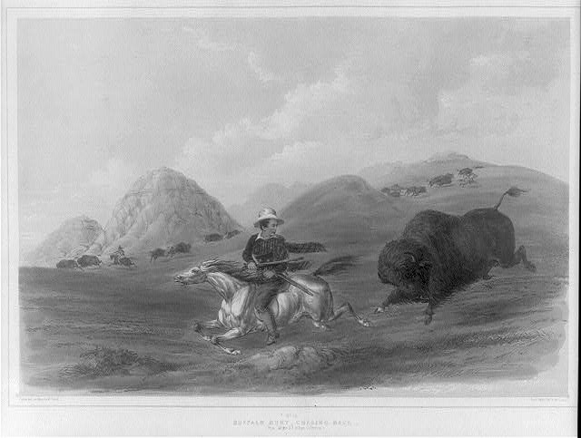
Turning the tables. The Huntington Library

Please analyze the various understandings of nature in any treaty made by the United States and one or more Native American nations. It would help if you reproduced the treaty with your essay, but some are very long. Relevant sections reproduced would be fine. A good source for your research here would be the Avalon Project. Avalon Project - Documents in Law, History and Diplomacy (yale.edu)

Built upon a search of a relevant text for the word “nature,” please describe the meaning(s), use, and power of the word and concept in any work by James Fenimore Cooper, Margaret Fuller, Herman Melville, David Foreman, Jack London, Willa Cather, Frederick Douglass, Mary Oliver, Sandra Cisneros, Octavia Butler, or Annie Dillard. Choose one author (but you may write about several works). You may propose a different author, but it has to be approved in advance of your working on the assignment.

Drawing upon at least three historical or literary sources that refer to “Mother Nature,” explain the gendered and maternal settings and meanings thereof. Why not Father, Brother, or Sister Nature?

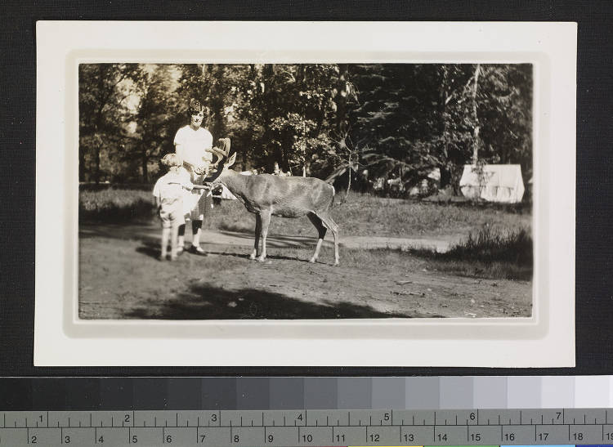
Woman, child, deer, circa 1900. The Huntington Library

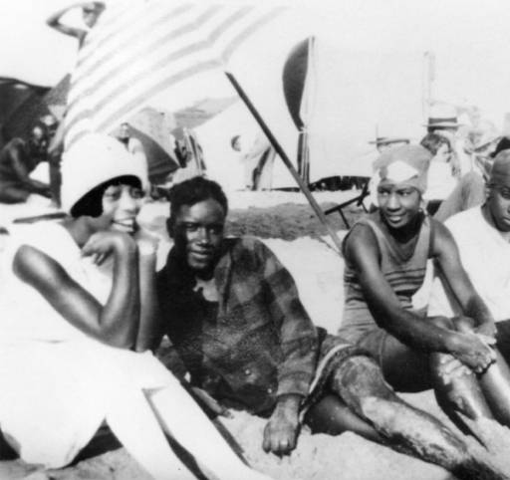
Group at “Ink Well” [segregated portion of Santa Monica beach] 1926. Los Angeles Public Library

Assignment Three. Final Essay. In an essay of 3,500 to 4,000 words covering at least a century of United States history (though try not to extend too far; 100 years is plenty in most cases), please analyze and interpret changing perceptions of nature by reference to one of the following genres of expression or knowledge: photography; geology; animal rights; sermons/theology; painting; poetry; national policymaking; folk or other music; political speeches. Please limit your analysis to one or at most two of these (which you weave together thematically). You are free to suggest another media if you wish, though you must gain approval ahead of time. How can you be sure that your examples reveal change beyond coincidental or circumstantial reasons?

Please be certain to elucidate and illuminate change in your essay. Please footnote/endnote/otherwise cite as needed. Please include a bibliography of sources. Please do not utilize the internet as your sole resource. Please do not replicate work done in the shorter essay assignment. Due in hard copy by 4:00 pm on December 14th, History Department.

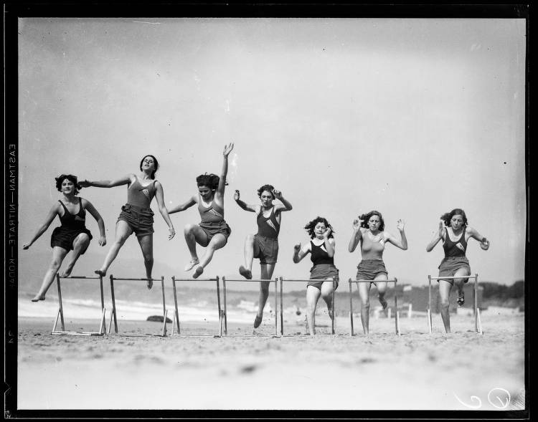
Women hurdlers, Santa Monica, 1927.

Questions and Feedback
I encourage this. Despite the challenges of the last several years, you are deep into the life of the university, and this transition from your younger self undoubtedly brings with it many, many questions. There are no dumb questions in college education. If you feel comfortable asking a question in class, raise your hand and fire away. If you would prefer to ask in quieter circumstances, please feel free to come to office hours or make an appointment or email me.

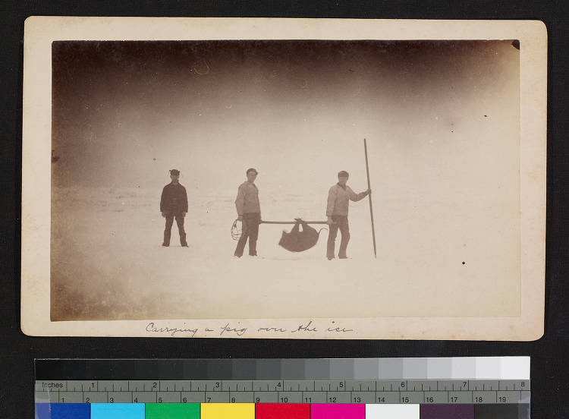
Carrying a pig over the ice. 1910s. The Huntington Library

Course Schedule
August 25th
Week One: Encounters and Consequences I
Introduction to course, readings, and assignments, and to one another in seminar.
Please begin William Cronon’s Changes in the Land (a couple of chapters).

Week Two: Encounters and Consequences II
September 1st
Please finish Cronon.

Week Three: Natives and Nature
September 8th
Please read Nathaniel Hawthorne’s May-Pole of Merry Mount, Ambitious Guest, and Young Goodman Brown short stories.

Week Four: The New Nation: A New Nature?
September 15th
Please read all of Walt Whitman’ Leaves of Grass. Spend some of that time reading aloud so you can hear the words and visualize the spaces, places, and nature as you do. Go outside.

ESSAY #1 due today

Week Five: Transcending Nature.
September 22nd
NO CLASS MEETING TODAY
Please read all of Henry David Thoreau’s Walden. Give yourself time.

Week Six: Regions, Animals, Emotions
September 29th
Please read William Faulkner’s The Bear.

Week Seven: Out West I
October 6th
Please read Stephen Pyne’s Year of the Fires.

NO CLASS OCTOBER 13th

Week Nine: Out West II
October 20th
Please read Norman McLean’s Young Men and Fire.

ESSAY #2 due today

Week Ten: Preserving Nature before or after the Fall
October 27th
Please read Rachel Carson’s Silent Spring.

Week Eleven: Convalescent Nature?
November 3rd
Please read Gary Snyder’s No Nature. As with Whitman, slow slow slow and try to go outside.

Week Twelve: Young Man and Nature
November 10th
Please read Jon Krakauer’s Into the Wild.

Week Thirteen: Aridity and Beauty, Anger and Love
November 17th
Please read Amy Irvine’s Desert Cabal.

NO CLASS NOVEMBER 24th
HAPPY THANKSGIVING. No class, but think about what Thanksgiving means in ideas about American Nature, Indigeneity, Bounty, etc. Mostly just take a break from school.

Week Fifteen: The Imagination and Wild Open Space
December 1st
Please read Annie Proulx’s Bird Cloud.

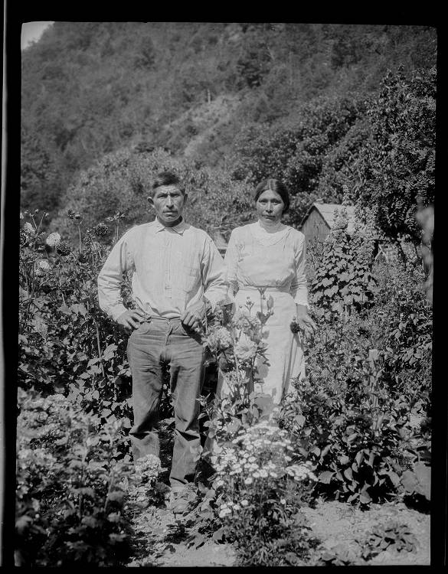
Unidentified Native American couple and their garden, ca. 1900.
The Huntington Library

