SPRING 2017
GESM 120: Childhood in America

Professor William Deverell
Department of History
University of Southern California
deverell@usc.edu

Tuesdays and Thursdays
12:30 – 1:50
Verna and Peter Dauterive Hall (VPD)107

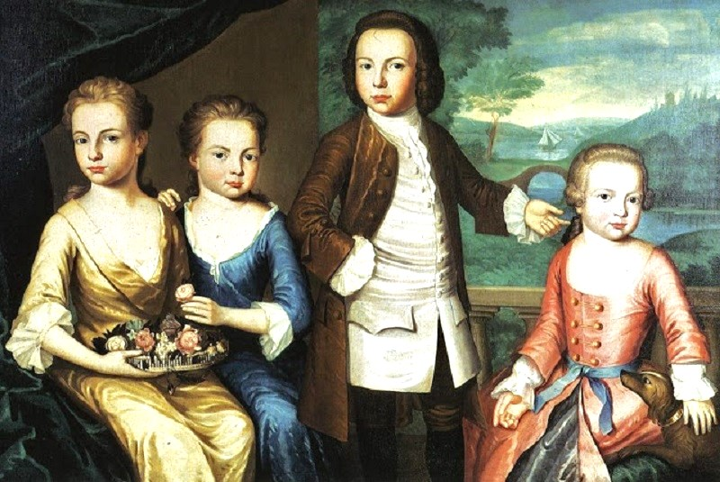

John Singleton Copley, The Gore Children, 1755.

This course is a seminar investigation of the history of childhood in America from the 17th century to the recent past. Our readings and discussions will focus on the ways in which ideas about American childhood – psychological, physiological, emotional, and otherwise—have changed over time. Our work together will explore such themes as child labor, child education, the rites of passage from childhood to adulthood, children’s recreation, and issues of demography, birth rate, infant mortality, and life and death rituals in regards to children. The seminar is designed around multiple disciplinary “takes” on childhood. What does the colonial era’s artistic perception of children as young adults tell us? What does a study of American public education tell us about understandings of children? How can fictional hero like Ragged Dick from the 19th century Horatio Alger stories illuminate ideas about childhood? What can we learn from Patty Reed carrying her tiny porcelain doll through the hellish circumstances of the Donner Party tragedy? How can Shirley Temple help us better understand the Great Depression and its impact?

Set against the background and sweep of American history, our seminar will illuminate specific issues on childhood and its dynamic history, as well as draw us into broader consideration of the social and cultural history of the nation.

Humanistic Inquiry Learning Objectives:
This course reflects on what it means to be human through close study of human experience throughout time and across diverse cultures. It also cultivates a critical appreciation for various forms of human expression, including literature, language, philosophy, and the arts, as well as developing an understanding of contexts from which these forms emerge. It seeks to engage with lasting ideas and values that have animated humanity throughout the centuries for a more purposeful, more ethical, and intellectually richer life. It will also push you to read and interpret actively and analytically, to think critically and creatively, and to write and speak persuasively. You will also learn how to evaluate ideas from multiple perspectives and to formulate informed opinions on complex issues of critical importance in today’s global world. Finally you will learn to collaborate effectively through traditional and new ways of disseminating knowledge.

Course Readings and Selections

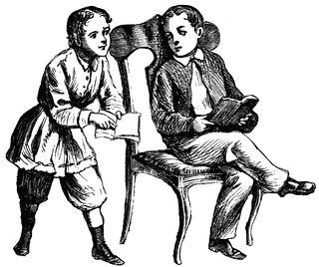

We will work through handouts on various themes and topics. I’ll get them to each member of the seminar with plenty of time to read them before we discuss.

In addition, we have five assigned books, all of which are available for purchase at the bookstore. .

Annie Dillard, An American Childhood

Tony Earley, Jim the Boy

bell hooks, Bone Black

John Kasson, The Little Girl Who Fought the Great Depression: Shirley Temple and 1930s America

Mark Twain, The Adventures of Huckleberry Finn

These are five very different books, held together by our common interest this term in American childhood. As you read them, think of the ways in which children are depicted, understood, interrogated, used as symbols, thought about, ignored, trusted, and mistrusted. What do they think, what do they wear, how do they perceive their world, how do they fit in? What’s American about their existence? What are their beliefs, fears, convictions, ideas, private thoughts? How do they interact with adults, and adults with them? How do they mark the divide between childhood and adulthood?

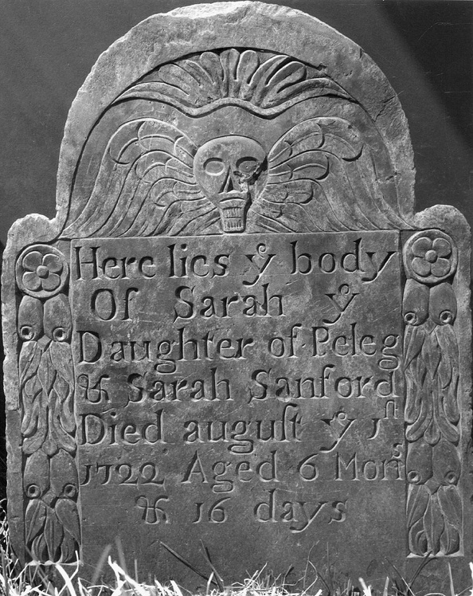

Course Assignments

Aside from attendance and energetic participation, you are required to give one in-class presentation this term (as discussed in a separate handout). You will also write two short essays for this class. One will ask you to focus on the era before 1900. Please define childhood as the culture does in the period/year you are working on, and please offer evidence for your definition(s). Please then write a 3-4 page double-spaced essay in which you identify a fictional child of that era and then describe for us a typical day in the life of that child: living conditions, clothing, daily life, food, obligations, thoughts, etc. You may, if you wish, do so in diary entry format or otherwise as a first-person narrative. Essay number 2, which you may extend to 4-6 pages, asks you to focus your attention on three images from three distinct periods in US history (photographs, paintings, other), separated by at least 50 years between images (i.e. 1850, 1900, 1950), each of an American child or of American children sometime in the 20th century. The images are to be depictions of children doing something similar in each era (playing, working, posing, etc.). Analyze the images: what is going on? What can you tell us by reading the images alone – about the subjects, about the contexts, about who this child is or who these children are? How is it that these subjects reveal truths about American childhood in the era depicted, and what has changed in terms of American childhood between your images 1, 2, and 3? It’s probably best to devote a page to each image, then a page or two to your comparison/analysis.

The final essay will be a take-home writing project at term’s end with multiple prompts to choose from. The final will draw on readings, handouts, and discussions all together. Your grade in the seminar will be based upon your participation/attendance (20%); in-class presentation 10%; two short essays (40%); and final (30%).

Course Schedule
I would like you to finish any given week’s reading by the Tuesday of that week. With the books, we will likely discuss them together on Thursday, which will give you a bit more time to be certain to be fully prepared.

January 10/12 Introduction to course and materials.
How do we study childhood?
Please read the handouts (Mintz, Stearns).

January 17/19
The Travails of 17th and 18th Century Childhood in North America
Please read the Romney handout

January 24/26
Patriarchy and Parenting in the Era of the Revolution
We will explore an early 19th century child’s “commonplace book” together.
No class January 26

February 7/9
The Unfree Child
Please read handout on first-person accounts of children and childrearing and age of consent graph. Please read David Hacker handout on fertility decline.
No class February 9th

February 14/16
A Motherless Thing
Please start Huck Finn and get through chapter XX
Please read Patty Reed handout

February 21/23
The Civil War: Childhoods Lost and Memorializing All
Please finish Huck Finn

February 28/March 2
The Civil War: Childhoods Lost and Memorializing All

March 7/9
The Late 19th Century and the Rise of Industrial America
Essay number one due start of class March 9th.

March 21/23
The Depression and The Power of a Single Child
Please read the Shirley Temple biography. We will screen The Little Colonel this week

March 28/30
The Depression
Please read Jim the Boy and the handout on letters to Eleanor Roosevelt
We will examine photographs of the destitute in greater Los Angeles, ca. 1935.

April 4/6
Race, Gender, Childhood in Post-War America Week One
Please read Bone Black

April 11/13
Race, Gender, Childhood in Post-War America Week Two
Please read An American Childhood

April 18/20
Faith and Fate and Fall: A Little Girl Lost, Los Angeles, 1949

April 25/27
I would like to screen the film Boyhood this week. It is a long film, so we will need to see if we can find 2.5 hours for it. Essay number 2 due start of class April 27th.

Week of May 1
Take home final essay, details to come.

Any student requesting academic accommodations based upon a disability is required to register with the Disability Services and Programs each semester. Please make certain that the appropriate documentation is delivered to Professor Deverell early in the term.

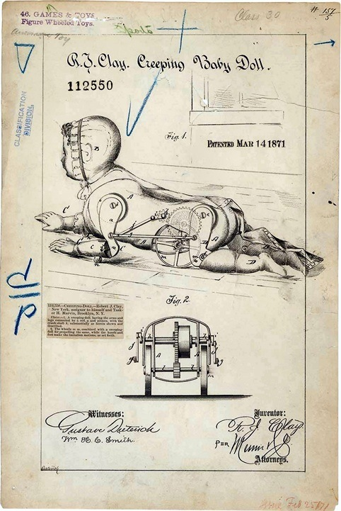

Designed to encourage babies to crawl, 1871.

