Oaxaca and Oaxacalifornia: Culture, Cuisine, and Biodiversity

Spring 2023
Dates: May 15 - June 9th (May 15-18th in Los Angeles)
e-mail: portnoy@usc.edu
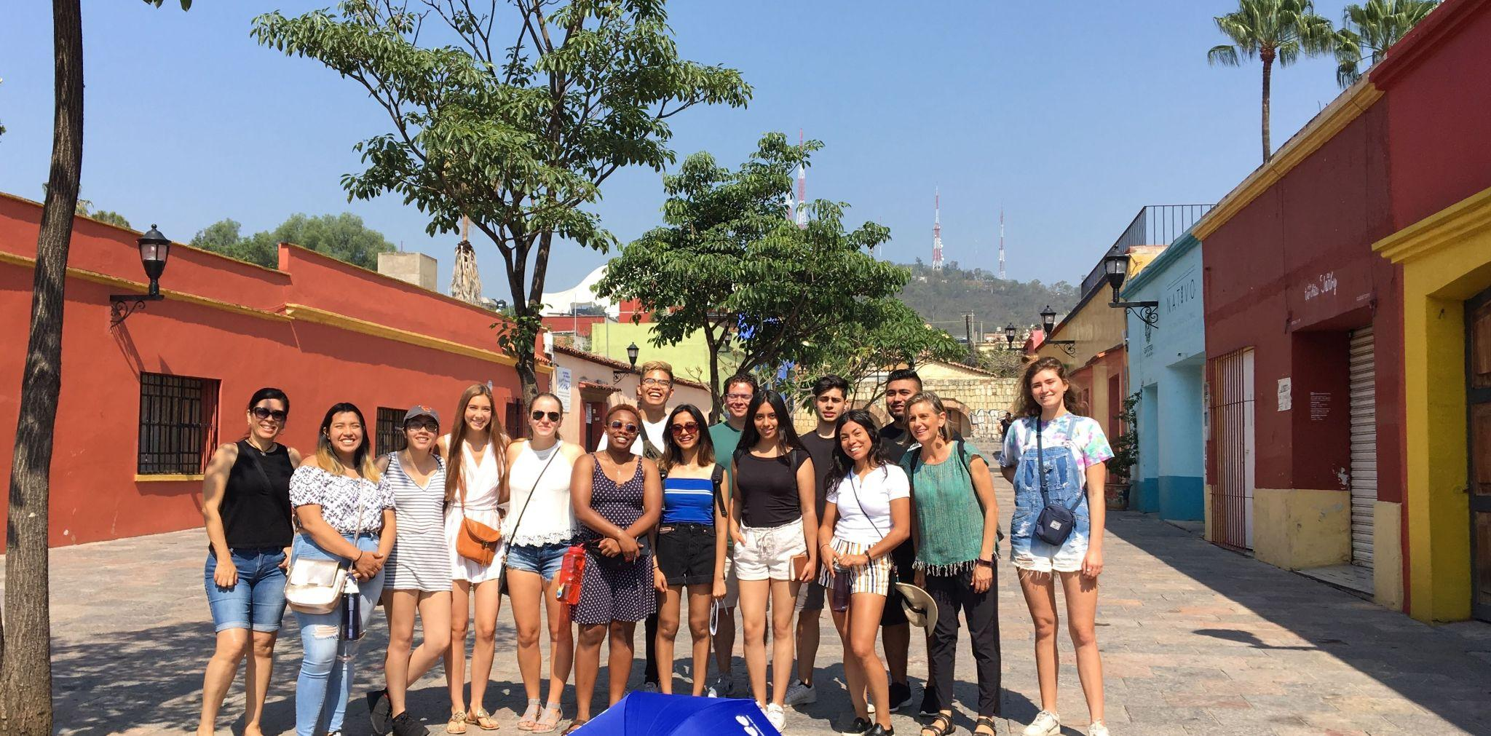
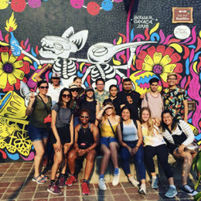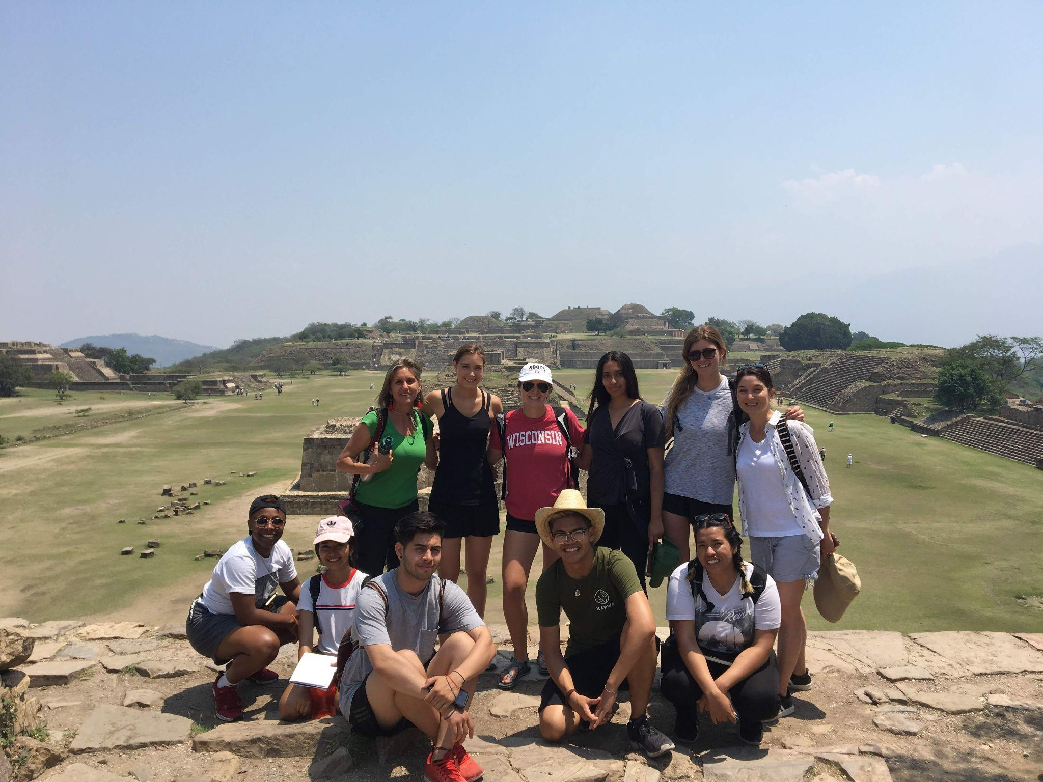

I. Course objectives:
- Experience firsthand the cultural, political, economic and spiritual value of Oaxaca’s nature, agriculture, traditional and street art
- Investigate Oaxacan culture on both sides of the border: Los Angeles and Oaxaca
- Discover traditional healings practices through herbs and other spiritual practices
- Explore permaculture (the development of agricultural ecosystems meant to be sustainable and self-sufficient) in the mountains, villages and coast of Oaxaca
- Learn about indigenous groups in Oaxaca that have developed local weaving cooperatives and small-scale ecological production.
- Get to know the coastal region and contrast its culture, cuisine and geography with the Central Valley and Sierra Norte Mountains
- Participate and learn about conservation efforts through turtle rescue.

II. Brief Course Description and Weekly Topics:
Oaxaca is a designated UNESCO World Heritage Site and is the most culturally and biologically diverse of Mexican states with sixteen different languages spoken in addition to Spanish, and environments as varied as desert, pine forest, and tropical rain forest.

The food of Oaxaca stands out as one of the richest and most diverse in all of Mexico. Based on a synthesis of Spanish and Indigenous legacies, Oaxacan cuisine is known for its many moles, complex sauces made of chilies, chocolate, herbs and spices; for its many corn products; for its mezcal, a locally cultivated, distilled beverage made from agave; and for the rich Oaxacan chocolate.

III. Weekly Agenda
Week 1:
Since Los Angeles is home to the largest Oaxacan community outside of Oaxaca City (an estimated 80,000), the course will begin with a week in Los Angeles introducing students to Oaxacan culture and cuisine through lectures with a Oaxacan cultural organizer, a visit to a local Oaxacan restaurant, etc. We will see how, in some cases, Oaxacan culture in Los Angeles has -changed as a result of immigration, while at the same time maintaining its own unique culture and cuisine.

Week 2: The second week of the program will begin in Mexico City. We will focus our visit on indigenous cuisine and culture from before the Conquest and in present times. On day 4, we will travel from Mexico City to the city of Oaxaca where we will be based for the remainder of the program. We will begin with a treasure hunt tour of the city center, a discussion on responsible tourism and a welcome dinner at one of Oaxaca’s most well-regarded restaurants. Next, we will have a bike tour of street art and meet a few artists at their gallery afterwards. We will go hiking in beautiful Hierve El Agua, a petrified waterfall an hour’s drive from Oaxaca.

Week 3:
This week we will travel out of town to local villages. We will spend one night in the small town of Teotitlán del Valle with the Women’s Cooperative where we will learn about their struggle for self-determination and empowerment. We will also learn about ecotourism and traditional medicine during a two night/three days in one of the Pueblos Mancomunados, indigenous villages that developed a communal ecotourism project in the 1990s that has become a model for all of Mexico. We will hike a pre-Hispanic trade route between the villages, learn about traditional medicinal herbs, and take part in a ritual cleansing (temazcal).
Week 4:
We will spend the last week of the program finalizing the ethnographic research projects in groups with some free time to work on them. Then, we will have a final getaway to the beautiful waterfalls of Santiago Apoala, where we will hike and stay in cabins overnight, before returning to Oaxaca for a final dinner before we head home.

IV. Course evaluation:

Participation 16%
Food Ethnography 20%
Presentation
Paper 16%
Reflections 48%
(8% each, 6 total)

A. Attendance and Class Discussion (19%) -- Attendance at each session is mandatory. Class discussions will be focused on readings and larger questions for the daily topic of study. This part of the grade will be determined by a combination of attendance, and participation in class discussions. Attendance at all field trips and excursions is mandatory as well. Except in cases of serious illness, attendance at all of the classes/excursions is expected, as they are an important part of the course.

B. Ethnography (Presentation and Written Observations)—In groups of 3, you will observe traditional practices in Oaxaca and its environs.
Suggested topics: a specific food or drink such as the tlayuda, mezcal, etc., the tradition of alebrijes, Street art, women artisans, traditional medicine, etc.
Each group will write up a short description and analysis of his/her observations, and answer the following questions in the course of your analysis:
If food is the focus, use the following questions to help guide you:
- How is the drink or dish prepared? Who prepared it?
- Who is dining? What binds the diners together?
- Is there an order to how the food is consumed?
- What choices have been made about what to consume and when?
-What ingredients are being used? Are they locally grown and purchased?
- Is there a history to the food being consumed? How do you know? Would this eating process have looked any differently three or five or ten decades ago?
- What supplements the food? Décor, conversation, etc.? Is the food secondary to the supplements? Or does the food come first?
- How are the food, ambience, or diners different in the U.S. from Oaxaca? Similar?

In 3-4 double-spaced pages, record your observations and then draw conclusions about the role of these traditions and rituals in everyday life in Oaxaca and in Los Angeles. You will be graded on the vibrancy of your description and analysis and the details supplied. Each group should also prepare a 10-12-minute presentation based on your observations. This presentation should summarize the basics of your ethnography and then conclude with the most interesting analytical elements from your description—reflecting on the experience.

D. Reflections. You will write 6 reflections on your experiences. These reflections should be detailed and reflect your reactions to experiences. What struck you? Why was this experience valuable? What did you learn about X? (More detailed instructions to follow.)

Suggested items for packing list:
Warm clothes for mountains
Hiking boots
Hat for sun
Lightweight Rain jacket
Quick dry clothes
Carry on size suitcase with spare duffle bag for short trips
Day Backpack
Water bottle
Mosquito repellant
Swim shirt/Bathing suit/Bathing suit cover up (women)
Flashlight
Small gift for host family (USC mug or LA souvenir?)

SCHEDULE OF CLASSES/ACTIVITIES:
Readings for May 16th:
- Intro a Oaxaca:

Readings for May 15:
- What Is Oaxacan Cuisine? - Eater
- Overview of OAX: https://en.wikipedia.org/wiki/Oaxaca
- Netflix “Street Food Latin America Oaxaca Episode (25 min)
- Stephen, Lynn, “Transborder Communities in Political and Historical Context: Views from Oaxaca,” and “Mexicans in California,” Transborder Lives: Indigenous Oaxacans in Mexico, California, and Oregon (Duke University Press, 2007), Ch. 1- p. 1-23, you can skim over dialogue, just get main concepts about migration and transborder (BB Content)
- Oaxaca: Oaxaca - HISTORY
- Video: Oaxaca: comunidad, colores y sabores: (up to Minute 12:20, Minute 19 to end) https://www.youtube.com/watch?v=On6rQiIgP4I
- One Day in Oaxaca (fun TV show, you can stop at minute 19, nice shots of the city): One Day in Oaxaca

May 15, Introduction to the Maymester (Monday) (10-12:30 PM, THH 121)
· Review syllabus/Meet Carlos de Coyote over Zoom
· Lecture on Oaxacan culture and gastronomy, Discuss readings
· Ethical Guidelines/Packing Tips

Reading:
Readings for Tuesday, May 16th.
- Documentary intro to Responsible tourism: “Crowded Out: An Overtourism Documentary,” Overtourism documentary by Responsible Travel
- “A Simple Guide to Ethnography,” http://www.dguth.journalism.ku.edu/Ethnography.html
- Colección fotográfica de la biodiversidad de Oaxaca: https://www.naturalista.mx/projects/biodiversidad-de-oaxaca?tab=species
- The Natural Wonders of Oaxaca: https://wildlatitudes.com/natural-wonders-of-oaxaca-mexico/
- Datos importantes Oaxaca WWF: Ver PDF

May 16, Tuesday. Class Hiking Day
9:30 AM·Baldwin Hills morning hike
· Discussion on readings at park

LUNCH

Readings for Wednesday:
- Bricia López, Introduction to Oaxacan Cuisine, PDF (BB Content)
- The winner of LA Times' 2021 Gold Award is Guelaguetza
- Ch. 1 Portnoy book –relevant section about Guelaguetza

May 17, Wednesday. Oaxacalifornia Day.
ZOOM to check in, turn in reflection
Time | Activity | Notes | Lectures / Resources
10 AM | USC CPA 110  Discussion on readings  Presentation from Oaxacan community activist

Readings for next week in OAX on weavers and street art:
For Saturday on Street art-
- “Representations of Resistance: Ironic Iconography in a Southern Mexican Social Movement,” Street Art of Resistance, p. 277-297 (BB)

May 18, Thursday–OPTIONAL TRAVEL DAY TO CDMX (Mexico CIty)
Time | Activity | Notes | Lectures / Resources
11:34 AM | Meet at LAX  T2 for Volaris  Flight is at 1:34 PM  Arrives 7:33 PM
7:30 PM | Ubers to Hotel in Centro CDMX
9 PM | Dinner at Azul  Histórico

May 19–
Volaris-Guadalajara–CDMX–7:13 PM Arrival
DINNER AT AZUL Histórico

May 20, Saturday. Mexico City’s Floating Islands and Archeology Museum
Time | Activity | Notes | Lectures / Resources
8:30 AM  9:30 AM | Meet at hotel lobby for breakfast,  Transport to Xochimilco |  | indigenous culture and agriculture
10 AM | Tour of Indigenous Agriculture of the Chinampas  Hosted by  Olintlalli Polo Téllez Xochimilco  Olintlalli, Ecoturismo en Xochimilco
1 PM | Lunch in the fields with  Professor Beatriz Ruiz Palacios, Professor of Sustainability
2:30 PM | Transport from Xochimilco to Anthropology Museum
3:30 - 5:30 PM | Private tour of Museo de Antropología with Prof. Alessandro Questa Rebolledo on Anthropology
5:30 - 6:15 PM | Time to explore Chapultepec park with the class
8 PM | Dinner on your own near the hotel. | I will give you a few local suggestions.

May 22, Sunday Exploring Mexico City’s Historic Center
Archeological sites, museums and views!
Time | Activity | Notes | Lectures / Resources
9 AM | Meet at hotel lobby for breakfast
10 - 2PM | Walking tour of the Centro Histórico  Templo Mayor Ruins and Museum  Zócalo  Catedral
2:00 PM | Lunch at Café Tacuba, historic restaurant in the Centro
3:30 PM | Tour of Banco de México Museum with designer Silvia Singer
4 - 5 PM | Bellas Artes Murals
6:30 PM | Sunset from the Mirador Torre Latinoamericana
8 PM | Dinner on your own in El Centro or nearby

May 22, Monday. Exploring Mexico City’s Center II.
Time | Activity | Notes | Lectures / Resources
8:30 AM | Meet at hotel lobby with suitcases  Day at Teotihuacán  Pyramids | Please make sure to have all of your belongings packed and ready to go
10:00 AM | Churros at el Moro in the Center
10:30 - 1 PM | Walking Tour of the Centro (Casa de los Azulejos, etc.)
1 - 3PM | Free time, lunch on your own
3PM | Meet at hotel to transport to airport
4 PM | Arrival to airport
5:26 PM | Flight departs to Oaxaca
8 PM | Arrive to Casa Magadalena in OAX–Welcome dinner at your B & B with host Magdalena Giron

May 23, Tuesday.Welcome to Oaxaca
Time | Activity | Notes | Lectures / Resources
8:30 AM | Breakfast at Casa Girón
10 AM | Welcome Ceremony at Casa Girón  We are hosting a circle to introduce ourselves. In this circle we will express our feelings, intentions, and goals for the trip.  A brief introduction to Oaxaca. | https://g.page/coyote-aventuras-oax-?share  http://www.instagram.com/coyoteaventuras  https://www.instagram.com/tierrasagradaoaxaca/ | Oaxaca: A land of amazing Diversity  https://indigenousmexico.org/oaxaca/oaxaca-a-land-of-amazing-diversity/  Please check the weather clima
11 AM | Oaxaca Treasure Hunt  A city tour that emphasizes agriculture, local traditions, cultural diversity, and street art. Students will get acquainted with the city and learn about what makes Oaxaca so unique. | Wear comfortable clothing. Bring sunscreen, sun glasses, and a water bottle. | Oaxaca History Resume  https://www.history.com/topics/mexico/oaxaca  “Las identidades étnicas en Oaxaca” (PDF under CONTENT on BB) https://www.academia.edu/36212149/Las_identidades_%C3%A9tnicas_en_Oaxaca  (p. P. 8-16, 20, 23-40)  “The Mixtecs and Zapotecs: Two enduring cultures of Oaxaca”  https://indigenousmexico.org/oaxaca/the-mixtecs-and-zapotecs-two-enduring-cultures-of-oaxaca/  “iNaturalist/NaturaLista/CONABIO”  https://www.naturalista.mx/  http://urtarte.blogspot.com/p/que-es-urtarte.html
3 PM | Free Time | Lunch on your own
8 PM | Dinner at Las 15 Letras  Talking about Oaxaca and its people is talking about mole, corn, and mezcal. | Meet at Restaurante Las 15 letras  https://goo.gl/maps/3L29EY9ix99be2nv7 | Why is Oaxacan food amazing?  http://www.culinaryartschool.edu.mx/cocinasdemexico/wp-content/uploads/2015/09/U10B5ACT1.pdf  Regional Mexican Cuisine: Oaxaca, the Land of a Thousand Moles  https://www.seriouseats.com/introduction-oaxacan-mexican-cuisine

May 24, Wednesday
Museum and Botanical Garden Day with Fundación Harp
Time | Activity | Notes | Lectures / Resources
9:45 AM  10-11 | Meet at the entrance to the Jardín Etnobotánico  Tour | Wear comfortable clothing. Bring sunscreen, sun glasses, a hat, and a bottle of water. | About the Jardín Etnobotánico de Oaxaca  https://tools.bgci.org/garden.php?id=3161  El Jardín Etnobotánico de Oaxaca: un santuario dentro de la ciudad  https://www.ngenespanol.com/traveler/como-visitar-el-jardin-etnobotanico-oaxaca/
11:30-1 | Stamp Museum Oaxaca | Guided visit with the Director of the Museo de la Filatelia. We will be able to observe a wide variety of stamps and collections of surrealist art. | Philately Museum of Oaxaca  https://www.mexicoescultura.com/recinto/49613/en/museum-of-philately-of-oaxaca.html
1:30 PM | Market Tour  The heart and soul of Oaxaca’s food culture can be found in the hustle and bustle of local markets. | We are having lunch at El Mercado de la Merced | The Indigenous Farmers Preserving Mexico's Native Corn  https://www.eater.com/22849244/oaxaca-mexico-corn-indigenous-farming-practices  A Tour of Oaxaca’s Best Markets  https://theculturetrip.com/north-america/mexico/articles/a-tour-of-oaxacas-best-markets/
4 PM | Visit Centro Cultural San Pablo | One of Fundación Harp’s many cultural spaces in Oaxaca city, Centro Cultural San Pablo is a setting for visual arts, photography, ceramics, and creative expression. | Fundación Alfredo Harp Helú  https://fahho.mx/filiales-fahho/centro-cultural-san-pablo/
5 PM | Visit Textile Museum | We will observe how textiles are intrinsically linked to Oaxacan cultures emphasizing how this ancestral art form is passed down through generations. Textiles tell stories that represent essential components of identity. | Oaxaca Textile Museum  https://museotextildeoaxaca.org/  Erick Mindling: Oaxaca, More than Fashion, A Place of Rootedness and Identity  https://oaxacaculture.com/2018/01/oaxaca-more-than-fashion-a-place-of-rootedness-and-identity-video/
8 PM | Dinner at home or on your own | We will provide a list of delicious restaurants around the city

May 25, Thursday. Mitla Caves, Mitla Archeological Site and Ancestral Explorations
Time | Activity | Notes | Lectures / Resources
8 AM | Breakfast Casa Girón
8:30 AM | Departure from Casa Girón
9 AM | Prehistoric Mitla Caverns - We will presenting a timeline of the Oaxaca Valley’s History and the domestication of corn | We will go on a short hike to explore the area. We advise students to bring adequate water, good hiking shoes, a hat and water.  Corn experience. Providing vestiges of ancient corn and squash. | Origins of Agriculture  https://sites.lsa.umich.edu/oaxaca-archaeology/origins-of-agriculture/  Prehistoric caverns  https://whc.unesco.org/en/list/1352/
11 AM | Mitla Archaeological Site | Guided visit to one of the Zapotec people’s most important archaeological sites. Mitla is a ceremonial center that combines Mixtec and Zapotec influences. | Experience Mitla  https://www.mexperience.com/travel/pyramids/mitla/
12:30 PM | Lunch in the Mitla Market
1:30 PM | Textiles / Embroidery in Mitla | Learn about Mitlas unique form of textile production and embroidery. Textiles are inextricably linked to Zapotec cultural identity. | Weaving in San Pablo Mitla  https://oaxacaculture.com/2019/12/weaving-in-san-pablo-villa-de-mitla-oaxaca/
3:30 PM | Return to Oaxaca City
4:45 PM | Free time and Dinner on your own | We can provide a list of excellent restaurants. Many vegetarian and vegan options are available as well.

May 26, Friday. Monte Albán: Oaxaca Food Experience
Time | Activity | Notes | Lectures / Resources
9:00 AM | Pick up at Casa Girón | Wear comfortable clothing. Bring sunscreen, sun glasses, a hat, and a bottle of water.
9:30-12 | Visit Monte Albán, the Zapotec people’s most iconic archaeological site | Monte Albán is a powerful archaeological site and is widely considered the most important site in the Oaxaca’s Central Valley region due to its architecture, hieroglyphs, tombs, and geographic location.  https://www.instagram.com/p/CYfOPxjpkX4/ | Zapotec Empire  https://www.colorado.edu/rioverdearchaeology/sites/default/files/attached-files/joyce_2016b.pdf  Monte Albán Archaeological Site:  https://www.wmf.org/project/monte-alb%C3%A1n-archaeological-site
12:30 | Market Tour  Explore the Benito Juarez Market / Sánchez Pascuas / 20 de Noviembre | Tour Oaxaca’s iconic central markets while you’re enveloped by the flavors and aromas of traditional Oaxacan cuisine.
5:00 | Lecture on Traditional Medicine con Claudia de Tierraventura at Casa Girón

May 27 and 28, Sunday. Traditional Zapotec Weaving in Teotitlán
Time | Activity | Notes | Lectures / Resources
8:30 | Breakfast  & Transportation | Grupo A Reyna- 10 personas leave for Teotitlán at 8:30  Grupo B Pastora- Sale a las 9:00
9:30 AM | Visit to Teotitlán del Valle  Spend day with Women’s Weaving Cooperative,  Vida Nueva, Visit Church  and Community Center | Vida Nueva  https://www.instagram.com/vidanueva_oficialoax/ | Teotitlán del Valle in California  https://oaxacaculture.com/tag/zapotecs-in-california/  “A Rug Weaver Searching for Social Justice in Oaxaca,” https://www.nytimes.com/2018/06/27/t-magazine/design/pastora-gutierrez-rug-weaving.html  “These Mexican Artisans Empower Women to Lift Themselves Out of Poverty,” https://www.globalcitizen.org/en/content/these-mexican-artisans-empower-women-to-lift-thems/  Documentary film:(76 minutes–watch a few minutes to get the idea): Woven Lives / Vidas Entretejidas:Contemporary Textiles From Ancient Oaxacan Traditions https://vimeo.com/397563463
3PM | Meeting in Pastora’s house
5 PM | Hiking to El Picacho | https://www.instagram.com/p/CK7gvpyn_C5/ | Teotitlán mysticism  https://coyoteaventuras.com/teotitlan-hiking/
8 PM | Dinner with your host family

May 28, Sunday. Traditional Zapotec Cooking in Teotitlán
Time | Activity | Notes | Lectures / Resources
9 AM | Cooking Class Group B | All day Cooking class in beautiful outdoor kitchen and Market shopping visit with Reyna Mendoza  We will learn about traditional cooking tools including a clay comal (flat griddle used to roast ingredients), a metate (large stone tool used to grind maize, chocolate, or dried chiles and spices for mole), and a molcajete (stone pestle and mortar) to make salsa. Followed by an amazing group meal!! You will love it!  Group A: Pastora Textile Experience | Reyna Mendoza: La Gran Cocinera Oaxaqueña  El Sabor Zapoteco: Meet Reyna
3 PM | Return to Oaxaca
4 PM | Free afternoon to work on ethnographic research | Consult with the Profe or the Coyote Team if you have any questions

May 29, Monday. Hierve el Agua + Mezcal Distillery
Time | Activity | Notes | Lectures / Resources
6 AM | Transportation to Hierve el Agua
8 AM | Hierve el Agua Hiking + Swimming & Picnic | Please wear comfortable clothing, sunscreen, sun glasses, bottle of water. .  Bring a swimsuit, towel and extra clothes. | Coyote Aventuras Hierve el Agua  Coyote Aventuras Hierve el Agua Hike  Hierve el Agua info
2 PM | Lunch at Mezcal Distillery | You will meet Jerónimo and his family, they are lovely people. | Jerónimo Mezcal: Instagram
3 PM | Mezcal experience | Conversation about Biodiversity, spirits, agriculture, traditions, etc. with local maestro mezcalero; Jerónimo | Q & A Mezcal for Dummies: Oaxaca-based co-founder of Neta  https://www.latimes.com/food/la-fo-what-is-mezcal-niki-nakazawa-neta-1-story.html  Biodiversidad de Agaves: Mezcal  https://relatosehistorias.mx/nuestras-historias/biodiversidad-y-mezcal

May 30, Tuesday. Sierra Mixe de Oaxaca: Ayutla and Tlahuitoltepec.
Time | Activity | Notes | Lectures / Resources
8:30 AM | Meet at Casa Girón  Transportation to Ayutla | Meet your host  Nación Mixe (@nacion_mixe) • Fotos y videos de Instagram  Please wear comfortable clothing, pack for 3 days and 2 nights.  Check weather conditions so you are adequately prepared | Cultura Mixe | Historia Cultural  https://www.gob.mx/inpi/articulos/etnografia-del-pueblo-mixe-ayuukja-ay  El Pueblo Mixe en Imágenes
10 AM | Ancestral Indigineous Cuisine - Breakfast | We will try an amazing ritual dish known as machucado.  Culture, handicrafts and ancestral indigenous cuisine tour – Unión Turística Nación Mixe A.C. (nacionmixe.com.mx) | El ritual gastronómico mixe de la abundancia (eluniversal.com.mx)
1 PM | Visit to Tlahuitoltepec - Discussion about cultural appropriation at Silvia Martinez’s ceramic workshop |  | https://www.vogue.co.uk/article/isabel-marant-plagiarism-claim-santa-maria-tlahuitoltepec-oaxaca  Tlahuitoltepec denuncia a la marca estadounidense Anthropologie por plagio de diseños textiles - Proceso  Apropiación cultural: México acusa a Levi’s de utilizar sin permiso diseños de artesanas indígenas oaxaqueñas | EL PAÍS México (elpais.com)
2 PM | Visit Fernando’s textile workshop |  | Los Jamás Conquistados: Nación Mixe
3 PM | Lunch with CECAM communal musicians | Exchange about artistry, learn about CECAM, hear some local music | Centro de Capacitación y Desarrollo de la Cultura Mixe  CECAM: Música del Mixe
5 PM | Overnight in Totontepec

May 31, Wednesday. Sierra Mixe de Oaxaca: Totontepec
Time | Activity | Notes | Lectures / Resources
8 AM | Breakfast
9 AM | Getting to know communal organization in Totontepec | We will explore the community in depth.  - The foundational site of Totontepec  - The “Centro Cultural Totontepecano” School  - The Municipal building  - The Cemetary  - Short walk around the project Pizca del Cielo (if the weather conditions are right).  In this walk we will have the opportunity to talk with the people involved in some of these communal projects.  We will also talk about the amazing corn of Totontepec. | El Pueblo Mixe  The Wonder Plant That Could Slash  Fertilizer Use  Indigenous Maize: Who Owns the  Rights to Mexico's 'Wonder' Plant? -  Yale E360
2 PM | Lunch in Sazón Mixe | To recharge energy we will have a taste of mixe cuisine.
7 PM | Dinner
8 PM | Night of mixe music with Honorio Cano | We will have the visit of the composer and director of the local band. He will play some of his music and talk about his compositions.

June 1, Thursday. Hiking the Sacred Sierra Mixe de Oaxaca:
Time | Activity | Notes | Lectures / Resources
8 AM | Breakfast
9 AM | Hike the Sacred Mountain Zempoaltepetl | Wear comfortable athletic clothing. Bring sunscreen, sun glasses, a hat, and a bottle of water. | El Zempoaltepetl: La Montaña Sagrada del Mixe
2 PM | Lunch
3 PM | Return to Oaxaca City

June 2, Friday, Cacao Workshop + Temazcal
Time | Activity | Notes | Lectures / Resources
11 AM  Be ready to leave 10:30 AM | Option 1-  Traditional Medicine Workshop and Ceremony with Tierra Sagrada  Option 2-  Cacao Sessions  Agriculture, history, workshop | Consult with the Profe or the Coyote Team if you have any questions  SIGN UP
4 PM | PM Activities:  Option 1 - Cacao Sessions  Agriculture, history, workshop  Option 2 - Traditional Medicine Workshop and Ceremony with Tierra Sagrada | SIGN UP

June 3, Saturday. Activists and NGO Community
Time | Activity | Notes | Lectures / Resources
9 AM | Street Art Walking Tour | Wear comfortable clothing. Bring sunscreen, sun glasses, a hat, and a bottle of water. | Coyote Aventuras Street Art Walk  Bouler Oaxacan Artist  URTARTE: Revolutionary Artist Collective
1 PM | Lunch
3 PM | Activities for the Afternoon:  Centro Esperanza Infantíl  Centro de Orientación del Migrante de Oaxaca  En Vía Microfinance Model | Activities are designed so that students can pick an NGO that they will volunteer at during our Volunteer Day. | Centro Esperanza Infantil  Centro de Orientación del Migrante de Oaxaca  Fundación En Vía
6 PM | Free time and Dinner on your own

June 4, Sunday. Spiritual Exploration
Time | Activity | Notes | Lectures / Resources
9 AM | Breakfast at Casa Girón
 | Free morning to work on ethnographic projects/  optional visit to Tlacolula Market on your own | Consult with the Profe or the Coyote Team if you have any questions
Reflection Circle - Invite members of the Traditional Medicine Community

Meditation
Discussion and Activity surrounding Mesoamerican Spirituality

June 5, Monday. Apoala: Mixteca Culture and Artisanry
Time | Activity | Notes | Lectures / Resources
8 AM | Breakfast at Casa Girón
9 AM | Leave for Santiago Apoala
12 PM | Local Mixtecan Lunch with our hosts
2 PM | Palm Basket artisan weaving workshop
4 PM | Compartencia and interexchange with chicos en Apoala (bridge building)

June 6, Tuesday. Apoala: Mixteca Biodiversity and Ecology
Time | Activity | Notes | Lectures / Resources
8 AM | Breakfast in Apoala
9 AM | Hike to the Cascadas  Bird watching, introduction to local ecology and swimming
1 PM | Lunch
 | Free time until agricultural visit
4 PM | Visit Milpa and learn about the Three Sisters agricultural system in the Mixteca

June 7, Wednesday. Return to Oaxaca City
Time | Activity | Notes | Lectures / Resources
8 AM | Breakfast in Apoala
 | Reflection Circle about Experience in Apoala
 | Leave for Oaxaca City
 | Dinner on your own

June 8, Thursday. Regenerative Agriculture and Final Presentations
Time | Activity | Notes | Lectures / Resources
8 AM | Breakfast at Casa Girón
9 AM | Transport to Villa Agroecológica Tierra del Sol
10 AM | Begin hands-on regenerative agriculture session | Activity will focus on what regenerative agriculture means and its implications for the future. Students will
1 PM | Lunch at Tierra del Sol
3 PM | Leave for Oaxaca

June 9, Friday. Vibrant Artisanry of Oaxaca: Alebrijes Workshop
Time | Activity | Notes | Lectures / Resources
9 AM | Transport to San Martín Tilcajete
10:30 PM | Alebrijes Workshop with Jacobo & María Ángeles  Paint your own alebrije! | Learn about this amazing ancestral craft and let your creativity wander as you paint your own alebrije. We will also cover María and Jacobo’s work in their community providing gainful employment in a horizontal way to halt massive out-migration to the US. | Jacobo y María Ángeles  https://www.instagram.com/jacoboymariaangeles/  Alebrijes, Tonas y Nahuales de la Cultura Zapoteca  https://www.youtube.com/watch?v=No9uqlVGn1s
1PM | Lunch at Almú  https://www.instagram.com/almu.uuuuu/?hl=en
3 PM | Return to Oaxaca City
4 PM | Final Presentations

June 10, Saturday, Packing and Final Dinner
Time | Activity | Notes | Lectures / Resources
 | Free time and time to pack
 | Be sure to bring back some souvenirs for family and friends
 | Final Dinner | Enjoy your last night in Oaxaca

June 11, Sunday, Travel Day
Time | Activity | Notes | Lectures / Resources
 | Travel Day Flight information TBD

Mon, Jun 12
8:08 AMOaxaca International Airport (OAX)
Travel time: 3 hr 6 min
10:14 AMLos Angeles International Airport (LAX)

IMPORTANT INFORMATION

Health Insurance
All USC students are required to have sufficient health and accident insurance protection during their study abroad program. All students on international special sessions will have USC coverage while abroad. Students who have waived out of USC-provided insurance for the spring semester will be enrolled in the USC additional ACE insurance for $92/month. There is no deductible on this plan. However, the USC insurance policies work on a reimbursement system, which means you will generally be expected to pay for your medical care and prescriptions out of pocket and then file a claim for reimbursement. When you submit a claim, you need to attach all of your receipts for payment. If your receipts are not in US dollars, you must also submit exchange rate information. If you do not have enough money to pay for service out of pocket, you can call International SOS to request guarantee of payment to the health service provider. Both types of USC health insurance include International SOS coverage. International SOS is a company that is on call to provide worldwide assistance 24 hours a day. International SOS coverage includes referrals to physicians, dentists, psychologists, clinics, and hospitals; medical evacuation; repatriation; and a range of other services. Students receive an International SOS card prior to studying overseas. Some important health-related websites:
http://www.usc.edu/student-affairs/Health_Center/ms.travel.clinic.shtml
U.S. Centers for Disease Control and Prevention: http://www.cdc.gov/travel/

Basic Safety Rules
Remember that in the country you are visiting you are a guest, thus always behave with this fact in mind. Be aware that all student conduct policies listed in SCampus apply while you are overseas. This includes the University’s policies on alcohol and drug use, as well as sexual misconduct. https://policy.usc.edu/student/scampus/

Recognize that the rules and recommendations given by your overseas program are in existence for good reason, and are often based on real-life experience. Be aware that being “foreign” does not excuse you from knowing and obeying the laws of your host country.
Make sure the director of the program, who is assigned the responsibility for your welfare, always knows where you are and how to contact you in an emergency. Give her your flight itinerary and other schedules if you are traveling by yourself.

If you decide to go out by yourself, always let your director and group mates know where you are going. Avoid impairing your judgment through excessive consumption of alcohol. Remember that, at all times, you are representing USC and USA.

Health and Safety Information to Keep in Mind when Traveling To Mexico
Dornsife College of Letters, Arts and Sciences at the University of Southern California urges students and parents to stay informed of conditions that may affect the health and safety of USC students abroad. Traveling and living in a foreign country always presents an element of risk. In a study abroad program as in other settings, students’ own decisions and behaviors can have a major impact on their own health and safety. There are many resources available to help students and parents better understand risks associated with traveling and living in foreign countries as well as precautions that can be taken. To aid students and parents in their consideration of potential health and safety risks, we have put together some information and provided links to readily accessible web sites that address issues of health and safety while abroad:
https://dornsife.usc.edu/health-and-safety/.

Statement on Academic Conduct and Support Systems
Academic Conduct:
Plagiarism – presenting someone else’s ideas as your own, either verbatim or recast in your own words – is a serious academic offense with serious consequences. Please familiarize yourself with the discussion of plagiarism in SCampus in Part B, Section 11, “Behavior Violating University Standards” policy.usc.edu/scampus-part-b. Other forms of academic dishonesty are equally unacceptable. See additional information in SCampus and university policies on scientific misconduct, policy.usc.edu/scientific-misconduct.

Support Systems:
Student Health Counseling Services - (213) 740-7711 – 24/7 on call
engemannshc.usc.edu/counseling
Free and confidential mental health treatment for students, including short-term psychotherapy, group counseling, stress fitness workshops, and crisis intervention.

National Suicide Prevention Lifeline - 1 (800) 273-8255 – 24/7 on call
suicidepreventionlifeline.org
Free and confidential emotional support to people in suicidal crisis or emotional distress 24 hours a day, 7 days a week.

Relationship and Sexual Violence Prevention Services (RSVP) - (213) 740-4900 – 24/7 on call
engemannshc.usc.edu/rsvp
Free and confidential therapy services, workshops, and training for situations related to gender-based harm.

Office of Equity and Diversity (OED) | Title IX - (213) 740-5086
equity.usc.edu, titleix.usc.edu
Information about how to get help or help a survivor of harassment or discrimination, rights of protected classes, reporting options, and additional resources for students, faculty, staff, visitors, and applicants. The university prohibits discrimination or harassment based on the following protected characteristics: race, color, national origin, ancestry, religion, sex, gender, gender identity, gender expression, sexual orientation, age, physical disability, medical condition, mental disability, marital status, pregnancy, veteran status, genetic information, and any other characteristic which may be specified in applicable laws and governmental regulations.

Bias Assessment Response and Support - (213) 740-2421
studentaffairs.usc.edu/bias-assessment-response-support
Avenue to report incidents of bias, hate crimes, and microaggressions for appropriate investigation and response.

The Office of Disability Services and Programs - (213) 740-0776
dsp.usc.edu
Support and accommodations for students with disabilities. Services include assistance in providing readers/notetakers/interpreters, special accommodations for test taking needs, assistance with architectural barriers, assistive technology, and support for individual needs.

USC Support and Advocacy - (213) 821-4710
studentaffairs.usc.edu/ssa
Assists students and families in resolving complex personal, financial, and academic issues adversely affecting their success as a student.

Diversity at USC - (213) 740-2101
diversity.usc.edu
Information on events, programs and training, the Provost’s Diversity and Inclusion Council, Diversity Liaisons for each academic school, chronology, participation, and various resources for students.

USC Emergency - UPC: (213) 740-4321, HSC: (323) 442-1000 – 24/7 on call
dps.usc.edu, emergency.usc.edu
Emergency assistance and avenue to report a crime. Latest updates regarding safety, including ways in which instruction will be continued if an officially declared emergency makes travel to campus infeasible.

USC Department of Public Safety - UPC: (213) 740-6000, HSC: (323) 442-120 – 24/7 on call
dps.usc.edu
Non-emergency assistance or information.

SHIRT SIZES–
- Aren-womens medium
- Hadee–male small
- Gabriela–women’s medium
- Fhernanda–women’s medium
- Jennifer–women’s medium
- Katrina–women’s small
- Esperanza–womens small
- Andrea womens’ XL
- Becca–womens medium
- Samantha–womens medium
- Finley–womens medium
- Enid–Womens medium
- Ari–womens small
- Isabela–womens medium
- Jonah–men medium
- Selene–small female
- Cole–Male large
- Profe P–womens small

