PSYC 499 MAYMESTER: Health and Mental Health Research in South Africa and Mauritius
https://dornsife.usc.edu/labs/susan-luczak/maymester-in-mauritius/

Spring 2021: May 17th- June 15th, 4 units
Instructor: Susan Luczak, Ph.D., Professor (Research) of Psychology, luczak@usc.edu
Accompanying Faculty: Jo Ann Farver, Ph.D., Professor of Psychology
Co-requisites: 1) Research Methods (e.g., PSYC 314), 2) Statistics (e.g., PSYC 274), and 3) either Abnormal (PSYC 360), Introduction to Clinical (PSYC 361), Developmental (PSYC 336), or an equivalent substantive course
Other requirements: 3.25+ GPA, CITI Human Subjects Training (prior to the start of travel)
To apply: fill out application at: dornsife.usc.edu/labs/susan-luczak/maymester-in-mauritius/

Overview: This course will focus on health and mental health research programs in Soweto, South Africa and Quatre Bornes, Mauritius. The overarching goal of this course is to help students begin to develop culturally competent research skills, including understanding of the environments in which the research is conducted and the contexts in which the outcomes should be interpreted. Students will learn about prospective research design, existing longitudinal health studies in these two nations, unique challenges of conducting international research, and ethical considerations in human subjects research. Experiences and excursions outside the classroom will provide a broader understanding of these societies, which shape approaches to physical and mental health. Assignments will include reading and presenting original research articles, preparing and presenting a literature review, quizzes, and a reflection paper. It is anticipated that this range of experiences will inspire students to expand their world views and think more deeply about how the processes they have learned about in their psychology courses apply in similar and divergent ways across societies.

Locations (if traveling, otherwise all online): Week 1: USC campus
Week 2: South Africa (Johannesburg) with Wits University DPHRU and Ekala Eco-farm and Eco-tours
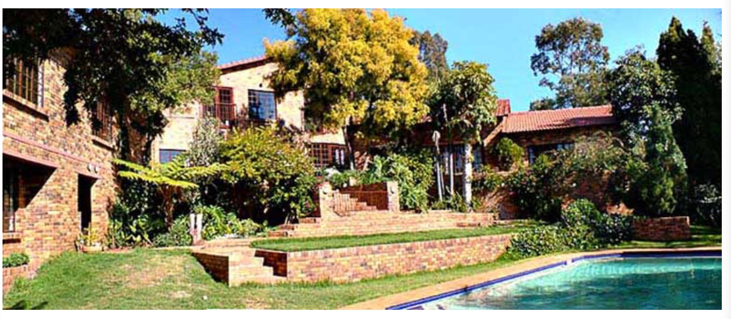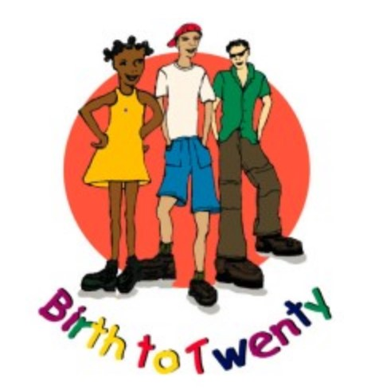
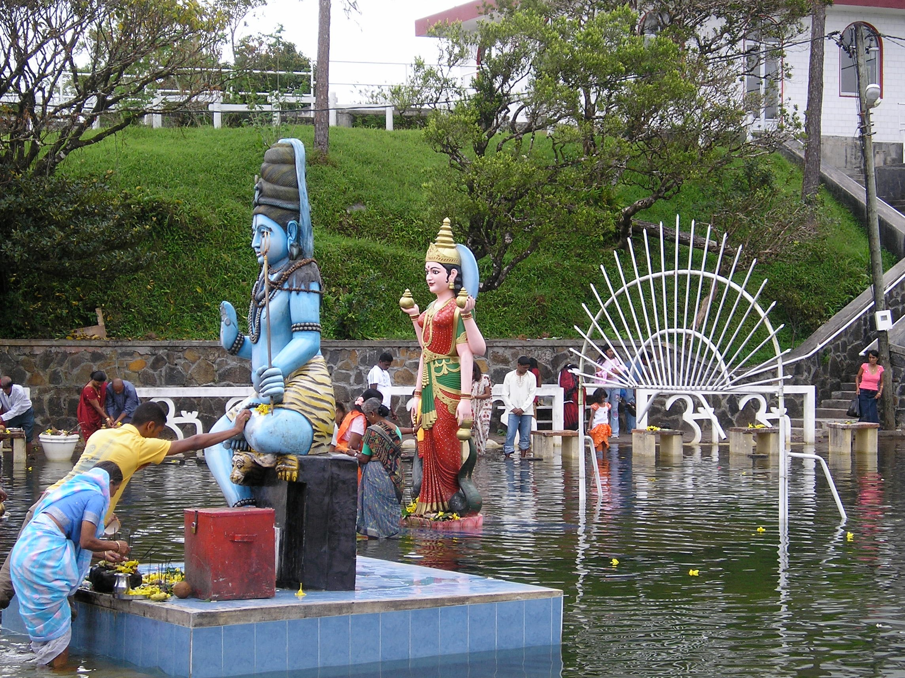
Weeks 3 & 4: Mauritius with Joint Child Health Project and The Sands Resort
