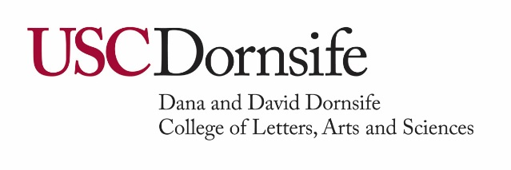
Guidelines for ExL reports
- The ExL Report is a one-page summary of your funded experience that will be submitted at the end of your opportunity. This report will be shared with the donors of your award.
- Type your report, save it as a PDF document and upload it to the link provided on your agreement.
- Include in your report:
  - Your name
  - Your major(s) and minor(s)
  - Your class year in school during the academic year
  - Your career goals and/or future plans
  - A description of the opportunity you experienced and the role you played. What did you discover or learn as a result of your experience?
  - A brief statement of thanks to your award donor. How has the donor’s generosity impacted you?
- Refer to your agreement or the website https://dornsife.usc.edu/exl/soar/ for report deadlines.
Sample EXL Report
With the support of the ExL Award and USC Dornsife Experiential and Applied Learning, I attended Columbia Business School’s inaugural Marketing and Creator Economy conference. This event brought together academic researchers and industry professionals from across the world—China, Belgium, Netherlands, South Korea, and the US, to name a few places! During this two-day conference, I listened to 40+ presenters share their research in the creator economy, networked with the 150+ attendees and presenters, and advanced future publications in the International Journal of Research in Marketing.
While I did not present any of my own research, I was pleasantly surprised by how much feedback I could share as just an audience member. Although initially nervous to ask questions or offer my opinions, being the only undergraduate student in a room of esteemed researchers, I realized that my experiences managing a YouTuber and studying International Relations Global Business and Global Health prepared me to participate in the event’s academic discussions.
This conference was my first taste of the graduate academic space, and I’m inspired to look into graduate business or media programs to further my interest in the creator economy. I hope to bridge my interests in global affairs and the creator economy by comparing the different guidelines, cultural nuances, and social media platforms around the world regarding this industry. Digital media and creators are the future of globalization, and it is essential to research how to navigate this. At this conference, I connected with a few researchers and graduate students in South Korea and NYC. I shared a few research ideas with them, such as studying the influencer pay gap or analyzing how the Korean Wave (Hallyu) shifted the American creator economy. I hope to keep these relationships and collaborate on making some of my research happen!
Thank you to the Dornsife Experiential and Applied Learning department and all the award donors for your generosity! Without it, I would not have been able to attend this conference and explore a genuine passion of mine. I truly learned from so many incredible individuals who inspired and challenged me. I could not be more grateful for my experience at this conference and excited for what’s to come!

USC Dornsife Admission and Student Success • 3709 Trousdale Parkway MHP 106 • Los Angeles, CA 90089-0453
scholarships@dornsife.usc.edu

