Abstract template for the July 2025 Erice workshop  
[Title: Times New Roman, 16p, Bold, centered]

[1 blank line after the title. Remove all text in red]

First Author1, Second Author2, and Presenting Author1,2

[Name: Times New Roman, 12p, centered, underline presenting author]

1Department of Vaporware, Vainglorious University, 111 Main Road, Central City, CA 54321, USA

2Sherlock Holmes Research Institute, 221b Baker St, Marylebone, London, NW1 6XE, UK

[Affiliation; Times New Roman,10.5p, centered]

[1 blank line after affiliation]

Please save your abstract **in PDF format** and email to [deamn@mail.com](mailto:deamn@mail.com) before April 20, 2025.

The workshop will have several slots for “hot topic” talks. The selection will be made from the abstracts submitted before the hot topic request deadline of March 1, 2025 [1,2]. [Font: Times New Roman, 10.5p]

Please do not change the page size, margins and spacing.

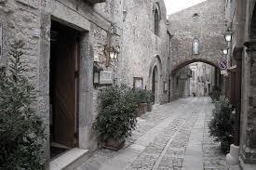

**Fig.1** Downtown Erice. [9p]

**References [**10.5p]

[1] J. J. Thomson, “Cathode Rays,” *Philos. Mag.* **44**, 293 (1897). [9p]

[2] H. W. Kroto, J. R. Heath, S. C. O'Brien, R. F. Curl, and R. E. Smalley, “C60: Buckminsterfullerene,” *Nature* **318,** 162 (1985).