Populating Holidays in Workday
Go to the employee’s Enter Time (timesheet) screen.
At the bottom left hand side, you will see the Enter Time menu.
Select Run Calculations.
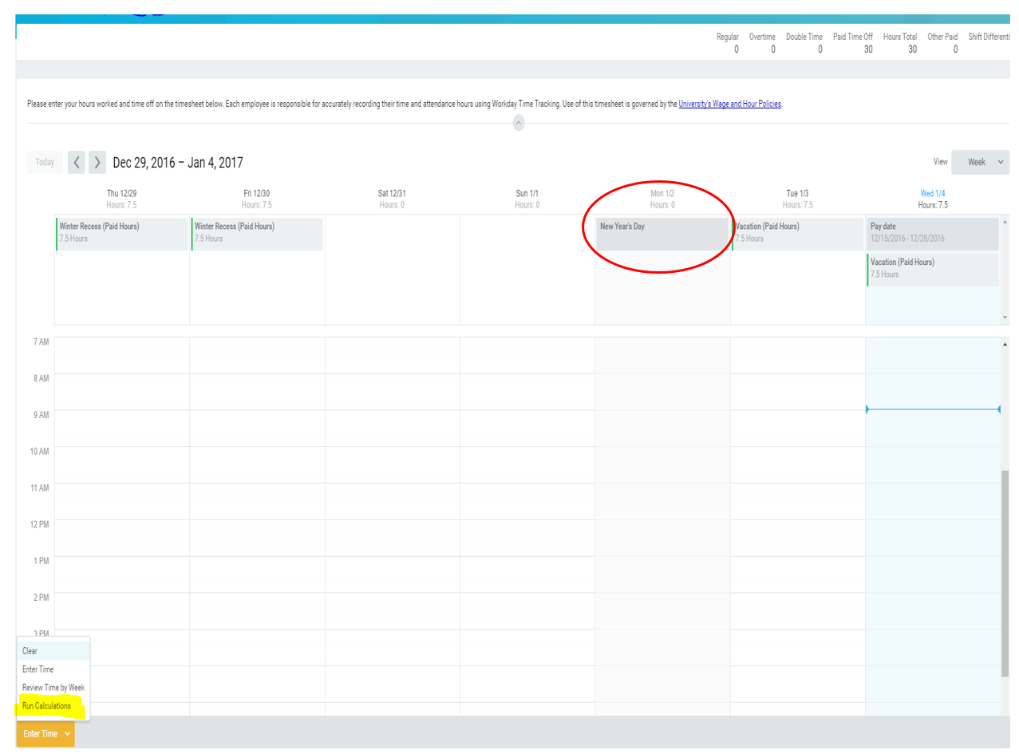
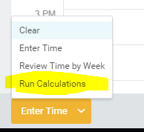
In the next screen you will confirm that you want to run calculations for the employee by selecting the check box next to Confirm and selecting the OK button on the bottom left hand corner.
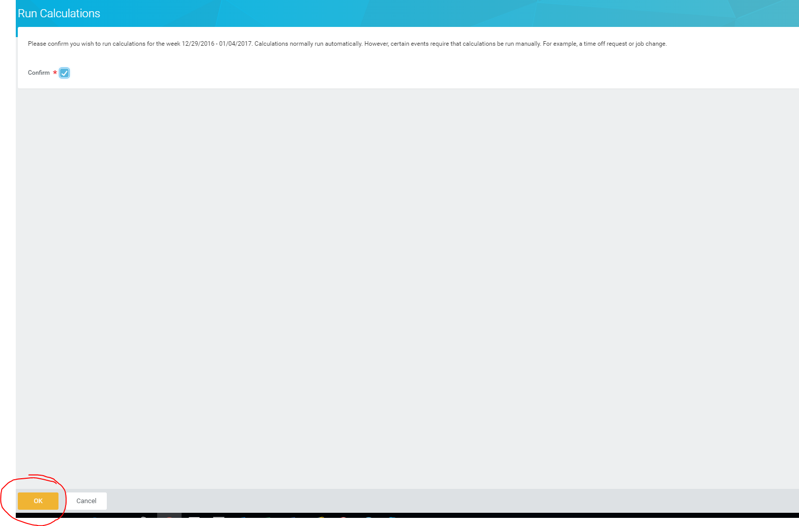
This will trigger the system calculations to determine if the employee is eligible for the holiday and how many hours are to be given.
The timesheet will now display the holiday hours on the timesheet.
